 | The CAMECA IMS 7f and 4f-E7 Software user’s guide  Analyses  00 45 633 906 - Type 108 – Indice B
0000.doc
(This documentation is relevant for the IMS7f the number of which is equal or larger than 715)
Index

Contents

1. Introduction 3
2. The Depth Profiling issue 3
2.1 Overview 3
2.2 Electronic gating, optical gating, gate ratio η_{GATE} 4
2.2.1 Electronic gating 6
2.2.2 Optical gating 7
2.2.3 The η_{GATE} gate rate 7
2.3 Ion detectors for counting mode. 8
2.3.1 Electron multiplier (EM) corrections. Dependence on the gating. 9
2.3.2 Faraday Sup (FC) channel settling time, definition of N_{faraday}. 10
2.3.3 Switching EM→FC and FC→EM 10
3. The Analysis program 11
3.1 Introduction 11
3.2 Analysis types 12
3.3 Enter / Exit program 14
3.4 Windows 14
3.5 The main Analysis window in definition mode 15
3.6 Defining a new analysis 17
3.6.1 New function 17
3.6.2 Save function 19
3.7 Opening a former analysis definition file 21
3.7.1 Open function 21
3.8 Definition window: analytical parameters 22
3.8.1 MAP (Main Analytical Parameters) 23
3.8.2 OIP (Optional Instrument Parameters) 23
3.9 Definition window: species table 26
3.9.1 Symbols 27
3.9.2 Mass species 28
3.9.3 Low species / High species 28
3.9.4 Low mass / High mass 28
3.9.5 Detector 29
3.9.6 Offset 29
3.9.7 Waiting time 30
3.9.8 Extra waiting time 31
3.9.9 Integration time 31
3.9.10 Magnetic field 31
3.9.11 Offset min, Offset max, step 31
3.10 Definition window: stop analysis conditions 32
3.11 Definition window: monitoring 33
3.11.1 Primary beam blanking 33
3.11.2 Beam centering 34
3.11.3 Sputtering rate 36
3.11.4 Crater depth 37
3.11.5 Reference signal 37
3.11.6 Mass calibration control 40
3.11.7 HV sample control 42
3.11.8 Data filtering 45
3.11.9 Pre-sputtering 45
3.11.10 Check Ip 46
3.11.11 O2 flooding 46
3.11.12 First point X/Y, Last point X/Y, Steps number 46
3.11.13 Image mode, Spatial resolution 47
3.11.14 Energy mode 47
3.11.15 dM mass step 48
3.11.16 Nb of data points / ΔM 48
3.11.17 Number of ΔM 48
3.11.18 Pre-cycle 49
3.12 The main Analysis window in acquisition mode 49
3.13 Acquisition window 52
3.13.1 Starting an analysis 53
3.13.2 Stopping the acquisition and saving raw data 54
3.13.3 Pause function 55
3.13.4 Abort function 56
3.13.5 X and Y axis display parameters 56
3.13.6 Stop conditions 57
3.13.7 Display of the analytical parameters 57
3.13.8 Analysis control window 58
3.13.9 Graphic display for the Image acquisition 59
4. Alignments 60
4.1 Depth profile 60
4.1.1 Low MRP ⎯ Large area profile 60
4.1.2 Energy filter ⎯ Large area profile 62
4.1.3 High MRP ⎯ Large area profile 64
4.1.4 Small area depth profile 66
4.2 Energy 68
5. Setup file parameters 70

Introduction

The second chapter of this document presents some major topics concerning the depth profile analyses, such as optical / electronic gating and ions detectors. The third chapter describes how to define and to control data acquisition using the Analysis program. The forth chapter describes the basic alignments. Setup parameters related with the Analysis software are listed in the final chapter.
Contents ↑

The Depth Profiling issue

Overview

As it is shown in the figure below, the progressive erosion of the sample gives access to the composition of inner regions. The removal of atomic layers by sputtering occurs with the same regularity as the peeling of an onion. However, the erosion disturbs the sample over a thickness which is not infinitely small. This thickness defines the so-called Depth resolution. Depending on the primary ion impact energy and other primary ion features like the incidence angle, the Depth resolution may vary between 1nm and more than 10 nm. Different physical phenomena such as atomic mixing, induced diffusion, recoil implantation or preferential sputtering are involved. They will not be discussed in this document.

An in-depth profile is obtained by recording the secondary signal as a function of time; the time scale is then converted into a depth scale by performing a time to depth calibration. Each point of an in-depth profile curve corresponds to given slice microvolume of matter sputtered during the point counting point.

Contents ↑

Electronic gating, optical gating, gate ratio η_{GATE}

As seen above, the SIMS way for performing an in-depth analysis consists of scanning the primary probe over the sample plane in order to dig a crater. The secondary ions coming from the crater bottom give the information corresponding to the crater depth d.
However, only a restricted area of the crater bottom is at the depth d since the crater edges are not sharp: The crater edge width is approximately equal to the primary probe size. It is therefore required to limit the analyzed area, by using either an optical gate or an electronic gate. The figures below illustrate these two types of gating. It is assumed below that the electronic gating is used with the Dynamic transfer mode (DTOS On).

Note: The Dynamic transfer system is based on deflection plates which are placed between the immersion and the transfer lenses. Synchronizing these plates with the primary beam rastering devices allows to modify the trajectory of the ions emitted and to make them pass through the center of the Field Aperture.

Contents ↑

Rastered area, sputtered area, flat crater bottom area, analyzed area

a) Electronic gating

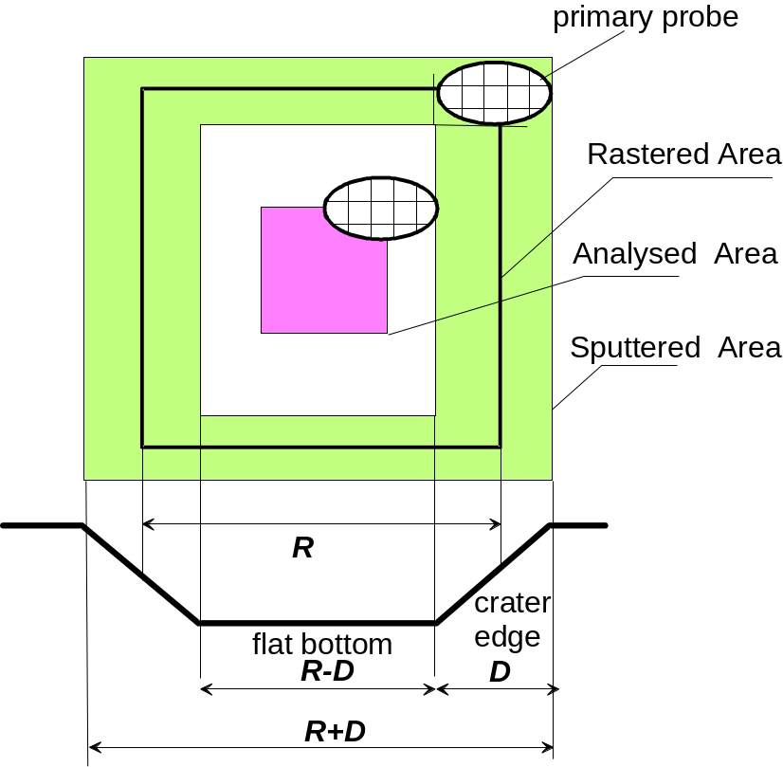

b) Optical gating

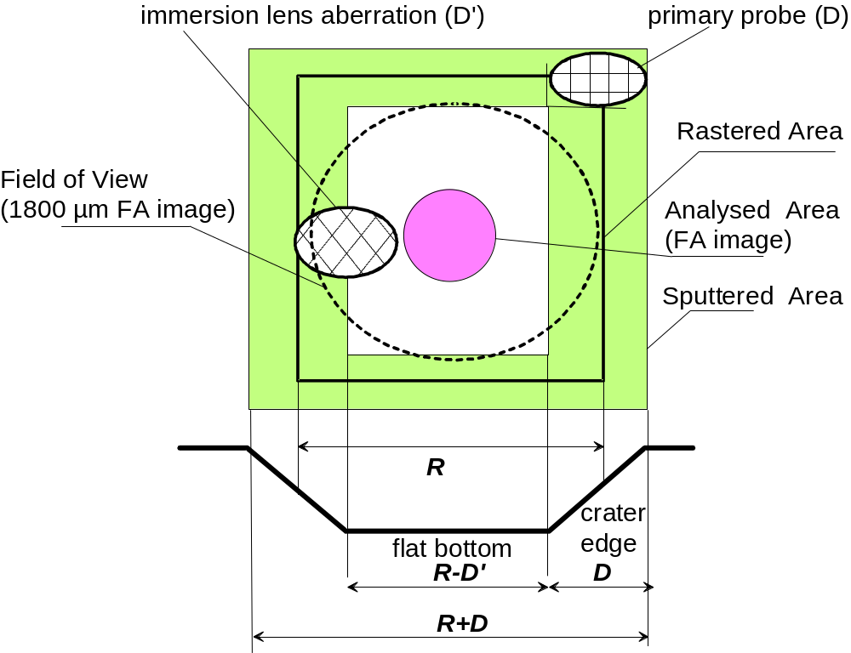

Contents ↑

The Rastered area R is the area which would be sputtered if the primary probe was infinitely small. It corresponds to the Raster value indicated in the Tuning interface and does not depend on the primary probe size.
Let D be the primary probe size. Note that one can distinguish Dx and Dy which may be different, but in the following, a single value D will be considered.
The Sputtered area is all the area damaged by the primary beam. It is actually the Rastered Area enlarged by the primary beam.
The crater flat area is the flat bottom of the crater.
All the above parameters depend only on the ion beam primary setting, probe and raster.

The Analyzed area must be entirely included within the crater flat area so that the measurement corresponds to a given depth. The secondary arrangements which allow to limit the Analyzed area may be an optical gate, an electronic gate, or both. For each case, a more detailed explanation is given below.

Rastered Area | R
Primary probe size | D
Sputtered Area | R+D
Flat Area | R-D
Analysed area (electronic gate case) | < R-2D
Analysed area (optical gate case) | < R-D  discussed below

Contents ↑

Electronic gating

As it was explained in § Primary ion optics, a sequencer determines a 1024x1024 pixels, rastered along a frame of 80 ms. The electronic gating consists of integrating, at each frame, the secondary signal over a W_{G}×H_{G} limited gate, smaller than the 1024x1024 frame. In the following, it will be assumed that W_{G}=H_{G}, the parameter Gate being defined as W_{G}/1024.

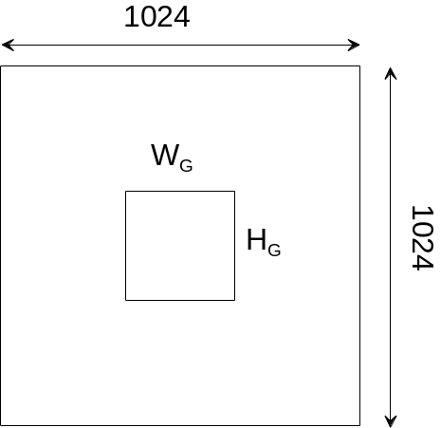

The electronic gating is achieved between the EM detector and the counter, by paralyzing the counting outside the gate.
It must be emphasized that the so-called electronic gate is actually a time gate and not a spatial gate.

The electronic gating must be used for limiting the analyzed scanned area when the Dynamic transfer (DTOS) mode is activated. It is also recommended to use it even if the DTOS is not activated in order to reinforce the optical gate.

The electronic gate size

The physical area corresponding to the W_{G}×H_{G} electronic gate is actually larger than W_{G}×H_{G}, since it results from the convolution of the W_{G}×H_{G} gate by the primary probe. This leads to the basic relationship, given above:

e-gate size < R-2D

If the primary spot is not well-defined, the question arises: "Which percentage of primary intensity can be accepted outside the Spot Size?". This is discussed below as the tail effect.

The tail effect

When a small part of the primary spot intensity is contained in a tail or a halo exceeding the expected size , the spot end may lick the crater edge during the e-gate time. This is particularly harmful if there is a large concentration difference between the edges and the bottom as it is the case for multilayer sample, where a species concentration may fall down sharply from 1 to zero. This case is displays below.

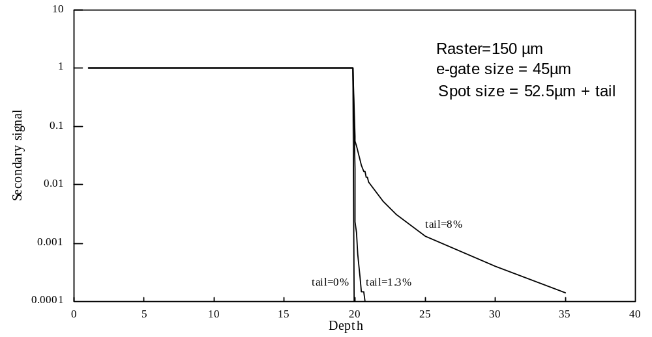

The above figure displays 3 profiles corresponding to different primary spot tails. "tail=x%" means that x% of the primary spot intensity is outside a diameter of 52.5µm. This last spot size is the theoretical maximum spot size corresponding to a Raster of 150µm and an e-gate of 45µm, according to e-gate size = R-2D.

A tail or a halo leads to a loss of dynamic if the e-gate if the overall primary spot size is not taken into account in the e-gate size calculation.
Contents ↑

Optical gating

The optical gating consists of limiting the scanned field with the Field aperture (FA). The Dynamic transfer (DTOS) is not involved in the Optical Gating (DTOS Off). The figure above displays the FA plane as it would be if the transfer optics had no aberrations. The circular Analyzed Area is the Field Aperture image and the rastered area is an image of the sample rastered field in the FA plane, as it would be if the primary spot was punctual. The Field of View circle corresponds to the largest FA (1800 µm).
It is shown on this figure that the difference between the crater internal boundary and the analyzed area boundary must be equal or larger than the overall immersion lens aberration. If this immersion lens aberration is larger than the primary spot, the electronic gating would be more advantageous, but inversely, if the immersion lens aberration is smaller than the primary spot, optical gating may be more advantageous than electronic gating.
Contents ↑

The η_{GATE} gate rate

The previous two sections describe the two different ways may be used to achieve a gating: Electronic gating and Optical gating. It results from both optical and electronic gating, that the instantaneous count rate is not equal to the number of counts per frame divided by the frame time since within a frame all the counts are concentrated within the gated area.
When running a Depth profile analysis, it is required to compute the so-called gate rate η_{GATE} for determining both the EM dead time correction (refer to the section below § Electron multiplier (EM) corrections) and the EM/FC switching level (refer to the section below § Switching EM→FC and FC→EM).
The gate rate η_{GATE} is the area ratio gate/frame. If all the counts occur over a gate, the instantaneous count rate is N_{C}/η_{GATE}, where N_{C} is the count rate averaged over the whole frame.

For determining η_{GATE}, the smallest of both electronic and optical gate must be considered.

- In the electronic gate case, the calculation of η_{GATE} is quite straight, since the electronic gate is determined as the square of relative side Gate:
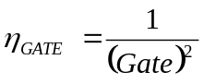

- In the optical gate case, both the Raster size and the Analysed area must be correctly calibrated. The Raster size is defined as the scanned field size. The Max Area is defined as the sample field diameter limited by the largest field aperture with diameter 1800 µm. So, the Analysed area is simply defined as
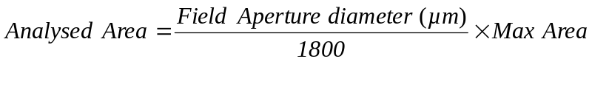
This analyzed area has the dimension of a diameter, whereas the η_{GATE} is an area ratio. Therefore:
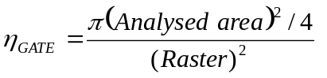
Contents ↑

Ion detectors for counting mode.

The IMS 7f and 4f-E7 are equipped with two types of ion detectors for the counting mode : one secondary Faraday cup (FC) and one electron multiplier (EM). The combination of both Faraday cup and electron multiplier provides a very high dynamic range for the secondary intensity measurements.

The Faraday cup and electron multiplier are used to measure count rates in the range [5×10⁵ ; 5 × 10⁹] and [10⁻¹ ; 10⁶] c/s, respectively. The overlap of the intensity ranges allows to combine both detectors within a given analysis. The two detectors are mounted side by side on the secondary beam trajectory after the second electrostatic analyzer of the instrument (projection part). The deflector located in front of the detector assembly is used to apply a fast switch of the secondary beam from one detector to the other.

Contents ↑

Electron multiplier (EM) corrections. Dependence on the gating.

Dead time τ

At a given accuracy, the highest secondary ion intensity which can be measured is limited by the time resolution of the pulse counting system. The so-called dead time of the pulse counting system is the time spent after each event before being able to detect the next one.

Let N_{c} the number of counted pulses per second at the pulse counting system, and τ the dead time of this system. Assuming that the system was unable to measure during N_{c}*τ, it is possible to deduce the EM output count rate N'

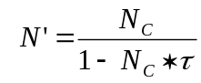

This is the basic dead time correction formula. For a dead time of 25 ns and a true pulse rate of 10⁶ pulse/s, a dead time correction of 2.4 % must be applied to the counted rate. As it can be easily corrected by a mathematical formula, the EM dead time is not an instrument limitation, providing τ is precisely known.

EM detection Yield Y_{EM}

The EM detection Yield Y_{EM} is defined as

Y_{EM} = (EM output pulse rate/EM input ion rate)

It can be measured on the instrument by comparing the measured EM count rate and the FC count rate in the range of 10⁶ c/s.

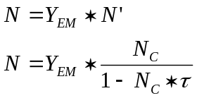

The dead time correction depends also on the gating

Whenever either optical or electronic gating is set (see above § The Depth Profiling Issue/Overview), the instantaneous count rate, within the gate, can be much larger than the measured count rate averaged over a frame. The dead time correction must therefore take into account the ratio η_{GATE}

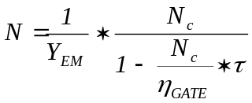

For determining η_{GATE}, both electronic and optical gate must be considered (refer to section § The η_{GATE} gate rate).

Contents ↑

Faraday Sup (FC) channel settling time, definition of N_{faraday}.

The FC channel response time is of the same order of magnitude as the frame time. Any FC measurement involved within an analysis must therefore take into account both the FC channel T_{FC} time constant and the required precision prec. It is therefore useful to define N_{faraday} as the number of frames corresponding to the FC settling time at a precision prec expressed in %.

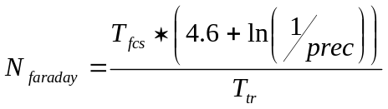

That leads to N_{faraday}=4.6 (rounded to 5) if prec=1% and T_{fsc}=T_{fcp}. The value of prec is defined in the Setup file (refer to the § Setup file parameters section). It is strongly advised to set this value to 1%.

This value is taken into account in Depth profile analyses when several masses are measured. In this case, for every cycle measured in FC, the first frames (the number of frames is given by the N_{faraday} value) are automatically cut and are not considered for the intensity measurement. The counting rate is averaged over the remaining frames only.
If only one mass is defined in a Depth profile analysis, and the measurement is performed in the FC, all frames are taken into account and the cutting of the N_{faraday} initial frames is not performed. When only one mass is measured, it is supposed that there is no need for the FC stabilisation time.

Important: whenever several masses are defined in a Depth profile analysis: for masses whose measurement will be performed using the FC detector, it is necessary to introduce an integration time corresponding to a number of frames higher than N_{faraday}. Otherwise, the measurement in FC will return a null counting rate since all frames will be cut by the N_{faraday} rule.

Contents ↑

Switching EM→FC and FC→EM

Hard security switching and Soft security switching

During an analysis, if the selected detector for a given mass is EM, the detector may switch automatically from EM to FC in two cases:
- If the count rate measured within one frame is larger than a Hard security threshold. This Hard security threshold is 2 500 000 counts per sec (cps). As the frame time is 80 ms, this corresponds to 1 000 000 count per frame. This is called the Hard security switching. It may be also triggered during the instrument Tuning. This security is targeted to protect the Electron Multiplier (EM) from an excessive ion bombardment.
- If the instantaneous count rate is larger than (η_{GATE} * Soft security threshold). Refer below to the section § η_{GATE} gate rate for more information about η_{GATE}. This Soft security switching is targeted to avoid the beam being measured outside the dead time correction range. Typically, the soft security threshold must be set to 4 000 000 cps .

Example: With an electronic gate Gate = 30% (that means that the gate width is 30% of the Raster size), η_{GATE}=0.09. For a Soft security threshold set to 4 000 000 cps, the detector is expected to switch to FC as soon as the count rate exceeds 360 000 cps. It will actually switch slightly lower (See below, the EM/FC switching hysteresis).

During an analysis, if the selected detector for a given mass is FC/EM (meaning that the detector is set to FC but the switching from FC to EM is allowed), the detector switches automatically from FC to EM:
- If the instantaneous count rate falls below (η_{GATE} * Soft security threshold). This switching is targeted to avoid that the FC channel works in a region (below 500 000 cps) where it is less sensitive than the EM.

During an analysis, if the selected detector for a given mass is FC the detector is set to FC and no switching from FC to EM is allowed.

Contents ↑

The EM/FC switching hysteresis

In order to avoid that the switching system (EM, FC) gets unstable whenever the measured signal is close to the Soft threshold, an hysteresis effect has been introduced in the thresholding. A hysteresis coefficient is written in the Setup file (refer to section § Setup file parameters). | 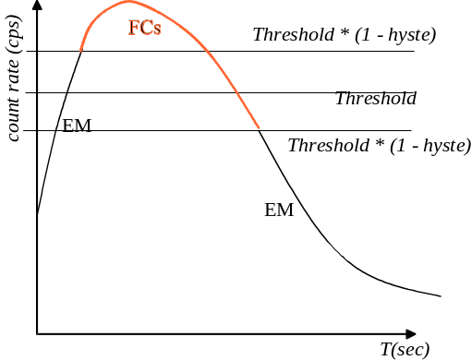

Contents ↑

The Analysis program

Introduction

The Analysis program main functions are:
- to define the acquisition procedure for a given analysis. Once the measurement conditions for a given analysis have been defined, they can be saved on the disk in order to repeat the same analysis later on.
- to control the current acquisition: to start, stop or abort the current acquisition, to display curves of species being analyzed, and to modify the total acquisition time of the present analysis.
Contents ↑

Analysis types

There are 7 different types of analysis available:
- Depth profile
- Line scan
- Image acquisition
- Energy
- High resolution
- Bargraph
- Mass spectrum

Depth profile

This analysis is used to record the variations of the secondary ion intensity for different species as a function of the sputtering time (refer to § The Depth Profiling issue). The signal for up to 20 different species can be recorded in a given analysis. One cycle contains one intensity measurement for every species to be analyzed. A depth profile analysis consists on the successive acquisition of cycles.
Contents ↑

Linescan

In this analysis, the secondary ion intensity for different species is measured on different positions of the sample stage. The sample stage can be moved by combining both X and Y motions together. The signal for up to 20 different species can be recorded in a given analysis. One cycle contains one intensity measurement for every species to be analyzed. A Linescan analysis consists on the acquisition of cycles, each cycle being recorded at a different sample stage position.
Contents ↑

Image

This analysis is used to acquire images. The images can be formed in either the scanning mode (scanning), or the direct mode using the microchannel plate (CCD), or the resistive anode encoder (RAE) if available. The images can be acquired with different formats ranging from 32×32 to 1024×1024 pixels. Every pixel is coded on 16 bits, therefore one image occupies 131 koctets in the format of 256×256 pixels or 2097 koctets in the format of 1024×1024 pixels. Images for up to 20 species can be acquired for a given analysis. The maximum number of images that can be stored in one image file is limited by the free space on the disk. One image plan contains one image recorded for every species to be analyzed. An image acquisition analysis consists on successive acquisition of images planes.
Contents ↑

Energy

This analysis is used to measure the variations of the secondary ion intensity as a function of the sample offset. This offset can be introduced: by changing the HV sample value directly (HV mode), or by changing the value on the spherical electrostatic sector (ESA mode). The increment of the sample offset and the scanned offset window are independently adjustable for each species. The secondary ion energy distribution for up to 20 species can be recorded in a given analysis. An energy analysis consists on the successive acquisition of energy distribution curves.
Contents ↑

Bargraph

This analysis is used to record a mass spectrum with a discrete magnetic field scan around the B field value corresponding to every integer mass included in the mass range defined by the operator. Up to 17 different mass ranges can be defined for a given analysis. A Bargraph analysis is recorded at a constant number of data points per peak width ΔM, which means that the B field step is variable over the mass range. A Bargraph analysis consists on the successive acquisition of elementary mass spectra.

Note: the peak width ΔM is defined as M/MRP, where M is the mass and MRP the instrument mass resolution.

An elementary mass spectrum is a mass spectrum recorded around an integer mass M, over the range [M−N*ΔM, M+N*ΔM] where N is an integer defined by the operator. This corresponds to a B field scan over the range [B_{i},B_{f}], B_{i} and B_{f} being computed as follows:

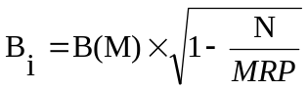

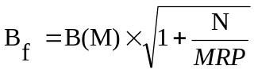

where B(M) is the B field value corresponding to the integer mass M, and MRP is the mass resolution of the instrument.
Over the elementary mass range [M−N*ΔM, M+N*ΔM], the mass is scanned with an increment δM = ΔM/n where n is the number of points per peak width ΔM.
Contents ↑

Mass spectrum

This analysis is used to record a mass spectrum with a continuous B field scan over different mass ranges defined by the operator. Up to 17 different mass ranges can be defined for a given analysis. A mass spectrum analysis is recorded either at a constant number of points per peak width ΔM, which means that the mass step is variable over the mass range, or at a constant mass step.
For a mass range [M_{i}, M_{f}] defined by the operator, the B field is scanned over the range [B(M_{i}), B(M_{f})], where B(M) is the B field value corresponding to the mass M.

Over the mass range [M_{i}, M_{f}], two scanning modes are possible:
- MR=cte mode: the B field is scanned with variable increment adjusted to keep constant the number of data points per peak width. The mass increment is δM = ΔM/n where n is the number of points per peak width ΔM.
- DM=cte mode: the B field is scanned with an increment adjusted to keep constant the mass difference between every data point. The constant increment δM is entered by the operator. It results in less data points per peak in low mass range than in high mass range.

Note: when a medium or high mass resolution is required for a given analysis, the mass spectrum program should be used over a limited mass range and for masses higher than 10 a.m.u. in order to keep a reasonable acquisition time. Another alternative is to use the Bargraph acquisition program to reduce the number of data points to be acquired, since in this type of analysis the B field is scanned around each integer mass only.
Contents ↑

High resolution

This analysis is used to record a mass spectrum with a continuous B field scan around different masses defined by the operator. Up to 17 different masses can be defined for a given analysis. A high resolution analysis is recorded at a constant number of points per peak width ΔM. For a given mass M defined by the operator, the scanning range proposed by default is [M−2*ΔM, M+2*ΔM]. The mass range can be modified by the operator. A high resolution analysis consists on the successive mass spectrum acquisitions around different masses.

Contents ↑

Enter / Exit program

In order to open the Analysis program, click the Analysis icon in the main icon board. The icon must turn from blue to red.
In order to iconize the program, click either the Analysis icon in the main icon board, or the symbol in the header of the Analysis main window. All windows and dialog boxes are closed. When the Analysis program is re-opened, all data included in the different windows and dialog boxes are restored with the same status as before iconizing the program.
In order to quit the program, click the symbol in the header of the Analysis main window. A confirmation prompt appears. If the quit operation is confirmed, the program closes one by one all the Analysis windows. Whenever a windows contain non saved data, a prompt appears asking the operator if data should be saved. The Analysis icon in the main icon board returns to the blue color.
Contents ↑

Windows

The Analysis program works with one common main window which contains as many sub-windows as required. The menus and buttons available in the main window depend on the type of sub-window currently activated. The windows can be of two different types:
- analysis definition windows: they contain the analytical parameters, the species table and the measurement conditions. When an analysis definition window is activated, the main window gives access to the Mass calibration program.
- analysis acquisition windows: they display the measured data online. Only the stop analysis conditions can be modified during the acquisition. An analysis acquisition window is automatically created from any analysis definition window either by clicking the Go analysis button in the main window toolbar or by selecting the Go function in the main window Analysis menu.

Analysis definition and analysis acquisition windows corresponding to different analysis types can be opened simultaneously in the Analysis program.
Contents ↑

The main Analysis window in definition mode

When an analysis definition window is activated, the main analysis window gives access to the following menus:
- File
- View
- Calibration
- Analysis
- Window
- Help

A Toolbar can also be displayed if this option is checked in the View menu. It gives access to the most common functions.
Contents ↑

File menu

In the File menu, the following functions are available:
- New: allows to create a new analysis definition window of a given analysis type. The New analysis dialog box opens.
- Open: allows to load a stored definition file of any analysis type. The Open dialog box opens.
- Close: closes the activated analysis definition window.
- Save: saves the activated analysis definition window. If it is the first Save operation, the Save as dialog box opens.
- Save as: allows to save the activated analysis definition window under a different name. The Save as dialog box opens.
- Print / Print preview / Print setup: not available yet in the definition mode.
- List of the four last saved definition file names.
- Exit: quits the Analysis program.

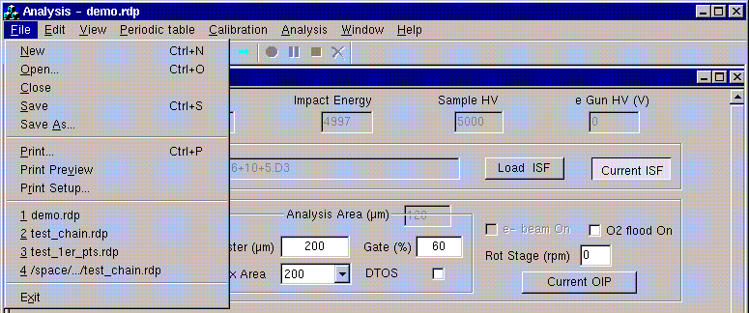

View menu

In the View menu, the operator can check/uncheck the Toolbar, Status bar options. If checked, the Toolbar, Status Bar will be shown.

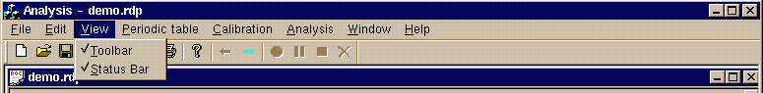

Calibration menu

In the Calibration menu, the following functions are available:
- Calib now: opens the Mass calibration program.
- Read table: updates the magnetic field values in the mass species table from the current main mass table B(M) (refer to § Mass_calib user's guide). Helpful when using an old analysis definition file.

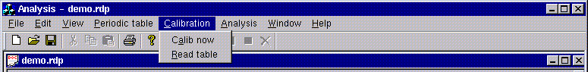

Window menu

In the Window menu, the operator can arrange the different analysis windows in different: New window / Cascade / Tile / Arrange icons.
The operator can also have access to any of the opened windows (analysis definition as well as analysis acquisition windows).

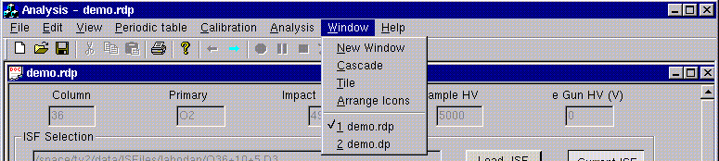

Toolbar

The toolbar contains buttons giving a quick access to several functions. By placing the cursor on a button, its function is automatically displayed.
Some functions are available only in definition mode, others only in acquisition mode.
From left to right, the buttons correspond to the following actions:
- New: opens a new analysis definition window.
- Open: loads a previously stored analysis definition file.
- Save / Save as: saves the present analysis definition or acquisition file, in the definition or acquisition modes respectively.
- Cut / Copy / Paste: not available yet.
- Print: available in the acquisition mode only.
- Help: not available yet.
- Go to definition mode: available in acquisition mode only.
- Go analysis: opens an acquisition window, available in the definition mode only.
- Start: available in acquisition mode only.
- Pause: available in acquisition mode only.
- Stop: available in acquisition mode only.
- Abort: available in acquisition mode only.

Contents ↑

Defining a new analysis

New function

By default, the Analysis program opens with a definition window of Depth profile type. If this is not the required analysis type, a new definition window must be opened either by clicking the New button in the main window toolbar or by selecting the New function in the main window File menu. In both cases, the New analysis dialog box opens.

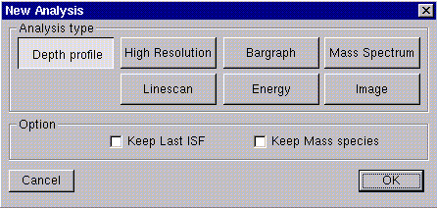

In the New analysis dialog box, the following functions are available:

- Analysis type buttons: they allow to choose the analysis type of the new definition window (Depth profile, High resolution, Bargraph, Mass spectrum, Linescan, Energy, or Image).
- Keep last ISF check box: check it to create a new definition window with the ISF (Instrument Status File) of the previously activated window.
- Keep mass species check box: check it create a new definition window with the species table of the previously activated window.
- Cancel button: cancels the opening of a new window. The New analysis dialog box closes.
- OK button: creates a definition window of the requested analysis type. The New analysis dialog box closes.

Once a new definition window is created, the operator must set all parameter values and options required to fully define the experimental conditions for a given analysis. These conditions are divided in three main groups:
- Analytical parameters: this group contains every parameter to define the hardware status of the instrument during the analysis. For instance: primary accelerating voltage, mass resolution, aperture sizes, …
- Species table: this group contains the species to be analyzed and their associated parameters (waiting time, counting time, detector,…).
- Monitoring: this group contains every option related to the computer control of the analysis procedure. For instance: beam blanking mode, reference signal measurement, mass calibration control,…

An example of analysis definition window is shown below.
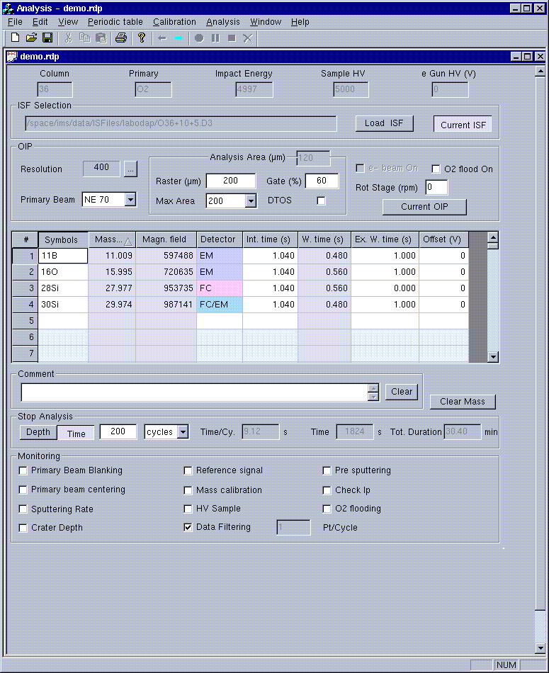

Contents ↑

Save function

By clicking the Save button in the main window toolbar or by selecting the Save function in the main window File menu, the operator can save all information displayed in a given analysis definition window. The same definition window can be recovered at any time by loading the corresponding recipe file. This capability is helpful if the same analysis has to be repeated later on.

Each analysis definition window is associated with a definition file. The file name is displayed on the header of the definition window. By default, if several windows of the same analysis type are created, they are sequentially named No_name_1, No_name_2, and so on. When a given window is either saved for the first time (Save function) or saved under another name (Save as function), the operator can enter a new file name.

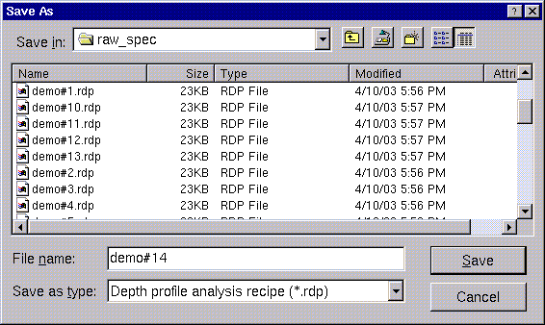

The extension of this file depends on the analysis type. The extension is automatically added to the file name by the program, according to the type of definition window.
The different analysis type extensions are reported in the following table:

Analysis | Analysis type extension
Depth profile | .rdp
Mass spectrum | .rms
Bargraph | ..rbr
High resolution | .rhr
Energy | .rnrj
Linescan | .rls
Image | .rim

Procedure to define a new analysis

- Click Analysis icon in the main icon board. The Analysis program opens with a definition window of Depth profile type.
- If required, open a new window by clicking New button in the main window toolbar or by selecting the New function in the main window File menu. The New analysis dialog box opens.
- Select the analysis type, and check the status of the Keep last ISF and Keep mass species options.
- Click OK button. A new analysis definition window of the requested analysis type is opened.
- Check the values set for the analytical parameters. If required, enter other values or read the present status of the instrument.
- Enter the species to be analyzed in the species table.
- Select the status of the different acquisition options and enter the corresponding parameter values.
- If required, select the Calib now function in the main window Calibration menu to check the mass calibration.
- Click Save button on the main window toolbar or select the Save function in the main window File menu. A dialog box opens.
- The program suggests a default file name (No_name_#). If required, enter a new file name. The extension of the file is automatically attributed. Click OK button in the dialog box. If the file name already exists there is a confirmation prompt before overwriting. The header of the analysis definition window is updated with the new file name.
- Click Go analysis button to open the corresponding acquisition window. The program checks the coherency of the entered parameters. If mismatching parameter values are detected, there is a prompt asking for correction(s).
Contents ↑

Opening a former analysis definition file

Open function

The Open function of the main analysis window is used to load a former analysis definition file.
By clicking the Open button in the main window toolbar or by selecting the Open function in the main window File menu, the operator can load all information previously saved in a definition file.
The file to be opened is selected in a file list displayed in the Open dialog box. In the Files of type pull-down menu, the operator can select the analysis type of the files to be listed. The files can be displayed in (anti-)alphabetical order, in (increasing)decreasing size order, or in (anti-)chronological order by clicking the Name, Size or Modified buttons on the top of the list.

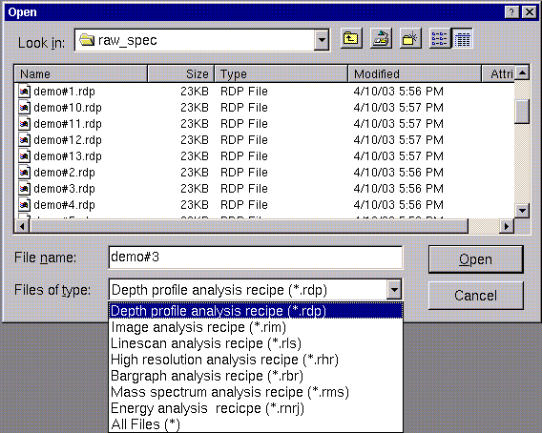

It may happen that the operator loads a recipe file which has been saved under a different ISF: in this case, the old ISF and MAP (Main Analytical Parameters) are automatically replaced by the current ISF and MAP. This is indicated by a prompt which asks the operator for confirmation. If confirmation is not given, the file is not loaded.

If confirmation is given, the updating of the parameters follows the rules:
- all MAP values are replaced by the current ones: Column, Primary ions, Impact energy, HV sample, eGun HV.
- The ISF selection field indicates the current ISF.
- The OIP (Optional Instrument Parameters) are not modified. If the OIP is defined by a preset, the same preset number is applied, but this preset has most probably a different label and corresponds to different parameter values in the current ISF.
- The species table and the Measurement conditions are not modified.

Note: The magnetic field values (in bits) corresponding to the listed masses are not automatically replaced. It is necessary to update the B field values for the current sample HV value by using the Read table function in the Calibration menu.

Procedure to load a former file of analysis definition conditions

- Click Analysis icon in the main icon board. The Analysis program opens with a window of the Depth profile analysis type.
- Click the Open button in the main window toolbar or select the Open function in the main window File menu. A dialog box opens.
- In the Files of type pull-down menu select the analysis type of the files to be listed. If required, change the directory or the order display by clicking Name, Size or Modified buttons.
- Click the name of the file to be loaded.
- Click OK button. If the ISF of this analysis definition file is different from the current one, a prompt appears indicating that the old ISF will be replaced by the current ISF. Click OK button to confirm. An analysis definition window with the experimental conditions stored in that file opens.
- If required, modify some of the parameters just loaded.
- Select the Save as function in the main analysis window to save the new parameters in a new recipe file on the disk.
- Click Go analysis button to open the corresponding analysis acquisition window. The program checks the coherency of the entered parameters. If mismatching parameter values are detected, there is a prompt asking for correction(s).
Contents ↑

Definition window: analytical parameters

The IMS 7f and 4f-E7 are partially computer controlled. All settings can be saved and restored in the Instrument Status File (ISF) except for the aperture settings which are manually controlled (refer to the § Tuning user's guide).

Within an ISF, some parameters are fixed, they are called the Main Analytical Parameters (MAP), whereas others can be varied, called Optional Instrument Parameters (OIP). A given ISF contains several possible configurations of each OIP.
For running an given analysis, a user must first select a set of MAP deduced from the analysis requirement. For instance, for measuring Arsenic in a Silicon matrix with high sputter rate, the user will select the Cesium as primary ions, 15keV as impact energy, and a negative secondary polarity. An ISF consistent with these MAP must previously be loaded from the computer disk.
Then, for defining an analysis, the user must precise the instrument conditions by selecting one among several of each OIP while using the same ISF. For instance, Raster=75µm or Raster=225µm, DTOS=On or DTOS=Off, FA=1800µm or FA=750µm, etc… The OIP allow to describe a complete instrument configuration with a reduced set of parameters.

It must be emphasized that some instrument parameters are independent on the particular ISF. They are stored in the Setup file (refer to the § Setup file parameters section) and will be used whatever the loaded ISF will be.

The analysis definition window displays the fields related to the status of the instrument hardware: MAP and OIP.
Contents ↑

MAP (Main Analytical Parameters)

These parameters are read-only, they are automatically filled by the program. In the actual version, an analysis definition file can only be defined for the current MAP of the instrument.

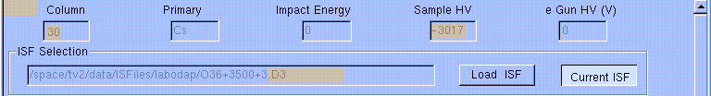

Displayed fields:
- Column: displays the primary column angle.
- Primary: displays the nature of the current primary ion beam.
- Impact energy: displays the current impact energy.
- HV sample: displays the extraction voltage applied on the sample.
- Egun HV: displays the e-Gun voltage value. If the e-Gun is not presently used, the value 0 is displayed.
- ISF selection: displays the present ISF filename and path.

Buttons:
- Load ISF: not available yet.
- Current ISF: the analysis definition file works with the ISF corresponding to the current status of the instrument hardware. This is the only mode available at the moment.

Contents ↑

OIP (Optional Instrument Parameters)

By default, when a new analysis definition file is created, the OIP fields are automatically filled with the values corresponding to the current setting of the instrument.
These parameters can be edited by the operator and may be set different from the current OIP conditions on the instrument (set in the § Tuning user's guide). The OIP values entered by the operator in the analysis definition window are applied on the instrument:
- when the mass calibration program is called (Calib now function in the Calibration menu),
- when starting an acquisition (refer to the section § Starting an analysis).
Note: this does not concern the aperture settings, which are manually controlled.

If there is a problem concerning the application of a parameter value, an error message appears.

The OIP are listed below. All of them have several configurations, contained within a single ISF. Each configuration is stored in a given preset.

OIP | Number of presets contained within one ISF
Primary beam | 10
Raster | 10
Max Area | 10
DTOS (ON/OFF) | 2
Electronic gate (Gate) | 10
Entrance Slit | 10
Contrast Aperture | 4
Field Aperture | 4
Energy Slit | 10
Exit Slit | 10
PBMF_A (Primary Mass Aperture) | 4
LPRIM4_A (Primary Beam Aperture) | 4

The Mass Resolution preset is a super OIP which reduces the set of 3 apertures Ent S, FA, and Exit Slit to a single parameter. Refer to the § Tuning user's guide for a detailed list of the parameters contained in each OIP.

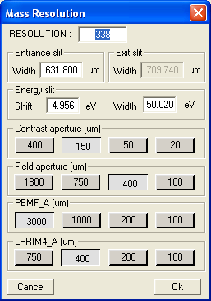

Mass resolution dialog box
It can be opened by clicking on the button just on the right side of the Resolution display field (see figure above).

- Resolution editing field: value of the mass resolution. The peak width ΔM is computed from the mass resolution MRP using the relationship:
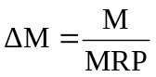
- Entrance slit width editing field: is used to enter the value of the entrance slit width (in μm).
- Exit slit width read-only field: it displays the computed value of the exit slit width (in μm) corresponding to the mass resolution entered in the resolution field.
- Energy slit shift / width editing fields: is used to enter the value of the energy slit shift and width (in eV).
- Contrast aperture buttons: they are used to select the contrast aperture diameter (in μm).
- Field aperture buttons: they are used to select the field aperture diameter (in μm).
- Auto button: it applies to all fields the values stored in the Mass resolution super OIP preset, whose mass resolution value is the closest to the Resolution value.

Note: the default values for these parameters are those corresponding to the current setting of the instrument.
Contents ↑

Primary beam scrolling menu

- Primary beam field: displays the label of the primary beam preset to be applied on the instrument. A scrolling menu can be opened by clicking on the button: it gives access to the primary beam presets defined in the Tuning program.
Contents ↑

Analysis Area parameters

For more details concerning the analysis area parameters, refer to the § Analyzed area section.
- The Analysis Area value, computed from the parameters: Raster, Max Area, Gate(%), DTOS is displayed next to the Analysis Area label.
- Raster editing field: is used to enter the value of the raster to be applied on the instrument.
- Max Area field: displays the label of the secondary beam preset to be applied to the instrument. A scrolling menu can be opened by clicking on the button: it gives access to the secondary beam presets defined in the Tuning program.
- Gate editing field: is used to enter the value of the electronic gate to be applied on the instrument.
- DTOS check box: when this case is checked, the Dynamical Transfer Optical System will be set On during the acquisition.
Contents ↑

Other parameters

- e-beam On check box: when this case is checked, the electron gun will be switched On onto the sample during the acquisition. This parameter is available only when the electron gun hardware is started.
- O2 flood On check box: not available yet.
- Rot Stage editing field: is used to enter the value of the rotation speed which will be set during the acquisition. This parameter is available only when the instrument is equipped with the rotation stage option.
- Rot Stage check box: is used to set the rotation during the acquisition. This parameter is available only when the instrument is equipped with the rotation stage option.

Contents ↑

Current OIP button

- Current OIP button: the OIP fields are automatically filled by the program with the values corresponding to the current setting of the instrument.
Contents ↑

Definition window: species table

The species table contains:
- Editing fields (white background color): symbols, integration time, extra waiting time, offset. The values can be entered after clicking on the corresponding editing field, and they can be modified by double clicking on the same field.
- Detectors editing field: the detector choice is made by clicking right mouse button.
- Display fields (gray background color): species mass, magnetic field, computed waiting time. These values cannot be directly edited.

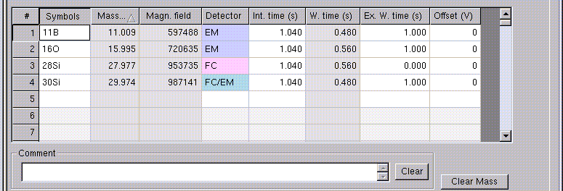

The species table may be longer than the displayed list. A scrolling bar on the right side of the species table gives access to the whole page. The maximum number of species or mass ranges to be analyzed per analysis is reported in the following table:

Analysis type | Maximum number of species or mass ranges
Depth profile | 20
Line scan | 20
Energy | 20
Image acquisition | 20
Bargraph | 17
Mass spectrum | 17
High resolution | 17

A comment can be added to the file by writing it inside the Comment editing field. This comment will be saved in the raw data file. The string entered by the operator can be erased using the Clear button next to the Comment field.

A Clear mass button is also available below the species table, which allows to clear the Species table from all species or mass ranges.
Contents ↑

Symbols

This editing field is used to define the species to be analyzed.
A species can be entered as a symbol or a mass number by using the keyboard.
The species are automatically put in the order of increasing mass in the table whatever the entering order carried out by the operator.

The syntax rules which must be used to enter a species symbol are represented in the figure below.
The characters of the element symbol can be capital or lower-case letters, but the different elements of molecular ions must be separated by a single space. The number of atoms for a given isotope is limited at 99, and molecular species cannot contain more than 10 different isotopes.
Note that for a given element, when the isotope mass is not entered, the program selects the major isotope.
The charge state is entered by using "+" symbol as shown below. The number of charges is limited to 3.

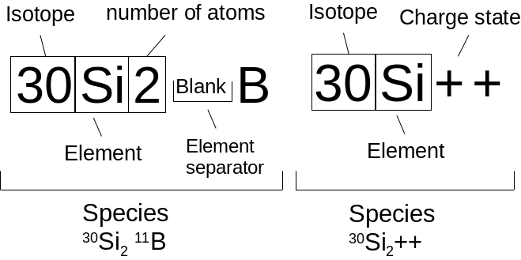
Two examples of syntax of species symbol in case of analyzing positive secondary ions.

Procedure to enter a species by using the keyboard

- Click in the first empty symbols editing field.
- Enter a species symbol or a mass number. Hit return on the keyboard to validate.
- The species is directly added into the species table at the correct position according to the increasing mass order.

Procedure to erase a species by using the keyboard

- Click on the "#" field corresponding to the line to be erased. The whole line turns into inverse video mode.
- Hit del key on the keyboard. The whole line in the species table is erased.
Note: the Clear mass button can also be used to clear the whole species table.

Contents ↑

Mass species

This field is for display only.
For every symbol species entered, the exact mass of the species is displayed in this field.

Contents ↑

Low species / High species

These editing fields exist for the Bargraph and the Mass spectrum analyses only.
They are used to enter the low and the high limits of every mass range (up to 17) to be scanned during the analysis.
- Low species: minimum value: 0.5.
- High species: maximum value: higher mass taken from the current B(M) table.

Both low and high limits of a mass range can be entered as a species symbol or a mass number. Both modes can be combined for the same mass range.

Every mass range defined by the low and high limits must be such that the difference between the two limits is less than 200 a.m.u.. If it is necessary to scan an interval larger than 200 a.m.u., several mass intervals must be defined.
Contents ↑

Low mass / High mass

These fields exist for the Bargraph, Mass spectrum, and High resolution analysis types only. They are display fields for the Bargraph and Mass spectrum, instead, they can be edited by the operator in the High resolution species table.

For Bargraph analysis:
- Low mass = closest integer to the Low species mass – N × ΔM
- High mass = closest integer to the High species mass + N × ΔM

For Mass spectrum analysis:
- Low mass = Low species mass
- High mass = High species mass

For High resolution analysis:
- Low mass (default value) = mass species – 2 × ΔM
- High mass (default value) = mass species + 2 × ΔM
Contents ↑

Detector

Default value: EM

Click right mouse button on the Detector field to open the detectors menu giving access to the following options:
- EM: the detector set for the measurement is the Electron Multiplier. However, if the counting rate is higher that the threshold EM→FC, the detector switches automatically to FC.
- FC: the detector set for the measurement is the Faraday Cup. The Faraday Cup detector will be used even if the counting rate is lower than the FC→EM threshold.
- FC/EM: the detector set for the measurement is the Faraday Cup. However, if the counting rate becomes lower than the FC→EM threshold, the detector switches to EM.

For more details, refer to the § Ion detectors for counting mode section.
Contents ↑

Offset

Default value: 0
Minimum value: -1000 V
Maximum value: +1000 V

For each species, a HV sample offset can be applied during the analysis. It can be different for the different species, except for the Image analyses where the offset value is common to all species.

Note: the application of a sample offset induces a primary beam position shift. The shift amplitude, proportional to the offset value, may reach several μm. Therefore, for an image acquisition, the same offset value must be applied for all species in order to form images from the same sample area. This is why the offset value is common to all masses in the Image acquisition analyses.

In order to correctly apply the energy filtering technique, the sign of the voltage offset must be entered as a function of the secondary polarity:
- For positive secondary ions: enter a negative offset to collect high energy secondary ions.
- For negative secondary ions: enter a positive offset to collect high energy secondary ions.

The offset values entered in the species table are added to the offset value which may have been already applied on the sample using the § Tuning program.
Contents ↑

Waiting time

This field is used for display only.
After a mass peak switch, the time to reach the correct peak position in the exit slit plane, within a given accuracy, is a function of the mass jump amplitude. Thus, a waiting time for the magnet stabilization is set for each species. For each species, the waiting time before starting the measurement is automatically computed using the following relationships:

If ΔM>0

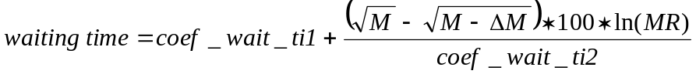
If ΔM<0

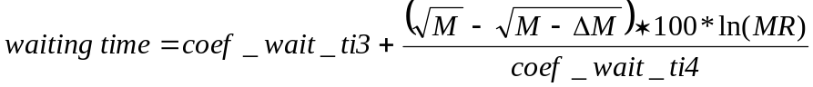

Where M is the mass species, ΔM is the difference between M and the previous mass in the species table (ΔM<0 for the first mass in the mass table only), MRP is the spectrometer Mass Resolution, and coef_wait_ti1 (Setup # 545), coef_wait_ti2 (Setup # 546), coef_wait_ti3 (Setup # 547), coef_wait_ti4 (Setup # 548) are Setup parameters.

Typical values
 | IMS 7f | IMS 4fE7
coef_wait_ti1 (s) | 0.5 | 0.75
coef_wait_ti2 (s) | 7000 | 10000
coef_wait_ti3 (s) | 0.4 | 0.9
coef_wait_ti4 (s) | 10000 | 10000

After this calculation, the values of Waiting time are rounded up to the closest integer multiple of a frame (0.08s).

The values of Waiting time are automatically recalculated each time the species list is modified, or the value entered in the Resolution field changes.
For example, with the typical values given above, the formulas give, for the IMS 7f, a waiting time of 0.87s (rounded up to 0.88s) for M = 56, when switching from mass 30 to mass 56, with a mass resolution MRP = 400 (M = 30 and ΔM = 30-56).

In the mass spectrum type analysis (Bargraph, Mass spectrum, High resolution), the operator can enter different mass ranges, with a gap between two consecutive mass ranges. The waiting time applied for switching from the last mass of one range to the first mass of the next range is computed using the same formulas.

Note that when only one mass or one mass range is analyzed, there is no default waiting time applied between masses or mass ranges.
Contents ↑

Extra waiting time

Default value: 0
Minimum value: 0
Maximum value: (800 s – value of Waiting time)

An additional waiting time can be entered by the operator in the Extra waiting time editing field. This value is added to the Waiting time value automatically calculated by the program. The sum of both waiting time values is limited to 800 seconds.
Contents ↑

Integration time

Default value: 1.04 s
Minimum value: 0.08 s
Maximum value: 800 s

For each species, a counting time per cycle must be entered. This value is always a multiple of the 0.08 s frame, each frame consisting of 1024 lines rastered along the X-axis.
If the value entered by the operator is not a multiple of 0.08s, the program returns the closest value multiple of 0.08s.
Contents ↑

Magnetic field

This field is used for display only.
For each species entered in the species table, the program displays the magnetic field corresponding to the mass species, this value being calculated from the current B(M) table (refer to the § Mass Calibration user's guide).
If a new mass calibration is carried out for the species to be analyzed, at the end of the mass calibration procedure, the B field values are updated in these editing fields. These new values can be saved or not in the main B(M) mass calibration table depending on the Setup parameter value #617.
At any moment, the operator can recall the magnetic field values from the B(M) table by selecting the Read table function in the Calibration menu.

Contents ↑

Offset min, Offset max, step

These parameters exist for the Energy analyses only.

Offset min:
Default value: -30 V
Minimum value: -1000 V
Maximum value: Offset max – 1

Offset max:
Default value: +30 V
Minimum value: Offset min + 1
Maximum value: +1000 V

Offset step:
Default value: +1 V
Minimum value: +1 V
Maximum value: +50 V

In the Energy analyses, for each species, the offset scan step and the low and high limits of the offset scan must be entered. The values of these parameters can be different for the different species.
Contents ↑

Definition window: stop analysis conditions

The operator enters the acquisition time which corresponds to a sputtering time (with Beam On). The stop analysis conditions can be modified during the acquisition.

Contents ↑
Default value: 300 cycles

For all analysis, the analysis time for a given analysis can be adjusted in two different ways by the operator:
- either by entering directly the overall acquisition time (in seconds or minutes): the computer then displays the number of cycles to be performed according to the parameters defined in the species table.
- or by entering the number of cycles: the computer then displays the total acquisition time according to the parameters defined in the species table.

The time value is entered in the editing field, it must be validated by hitting Return key on the keyboard.

The time units (cycles, seconds, or minutes) can be changed by opening the corresponding scrolling menu using the symbol. When changing the time units, the total acquisition time is kept constant within a given accuracy.
The Time/Cy. field displays the time corresponding to a cycle, according to the parameters defined in the species table.
The Time field displays the total sputtering time, during when the primary ion beam will be ON the sample. The Tot. duration field displays the real total time which will be required to perform the analysis. For example, if the Beam Blanking option will selected, the Tot. duration field will show the real time the analysis will take, whereas in the Time field only the sputtering time, which is shorter, will be shown.

Note: for a constant number of cycles, the total acquisition time can be adjusted by modifying the value of the acquisition parameters (for instance, the counting time for depth profile analyses, or the mass resolution and the number of point per peak width for the mass spectra type of analysis…).
Contents ↑

Definition window: monitoring

The monitoring settings cannot be changed during the analysis.
Contents ↑

Primary beam blanking

Default status of this option: No

When this option is active (selected case), the primary beam is blanked just before any mass peak switching and remains blanked until the end of the waiting time defined in the species table. This acquisition mode improves the depth definition of the recorded profile when a large number of species have to be analyzed, but at the expense of the acquisition speed.

The beam blanking mode has no meaning when only one mass is analyzed, since no waiting time is needed in this case.

When the primary beam is blanked, the clock of the analysis is stopped. Therefore, the time scale of the graph displayed in the acquisition window corresponds to sputtering time only (Time field).

Example: Let us assume an analysis recorded for 30mn, with a total waiting time equal to the total counting time for all species. The abscissa of the last data point is 15mn.

Procedure to run an analysis in the Beam blanking mode

- Check the Primary Beam Blanking option.

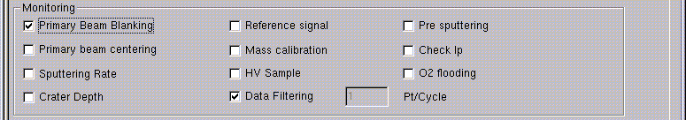

Contents ↑

Beam centering

Default status of this option: No

When this option is active (selected case), an alignment is performed between the primary beam position and the Field Aperture axis (which is itself aligned with the spectrometer axis).
This beam centering is performed according to the following principle: when the dynamic Transfer Optical System is Off, and the raster size is larger than the scanned field limited by the Field Aperture, the scanned image represents the position of the Field Aperture with respect to the crater. If this position is not centered, it means that the primary beam is not aligned with the spectrometer axis.
In order to realign the primary beam axis with the Field Aperture axis, it is possible to use either the primary beam position deflectors or the transfer dynamic deflectors.

For a Beam centering control, the operator must define the following parameters:

- Species: reference species, it must belong to the analysis species table and have EM as selected detector.
- Integration time: the ionic image is scanned during this time period.
- Threshold: this parameter is still not available, keep it to 0.
- Primary beam centering / Secondary beam centering: either the primary beam position deflectors or the secondary transfer deflectors will be used to perform the centering.
- In-situ centering / ex-situ centering: if the in-situ mode is chosen, the beam centering control is performed on the same point of the analysis; instead, if the ex-situ mode is chosen the beam centering control will be performed in a different point. In this case, the operator defines the control point by giving the distance from the analysis position (Shift position).

Note: the beam centering correction is computed from the values of the Raster, Field Aperture, and Max Area. It is therefore important to correctly calibrate the Raster and Max Area presets, and to set the correct Field Aperture position in the OIP Mass resolution dialog box (refer to the § OIP (Optional Instrument Parameters) section).

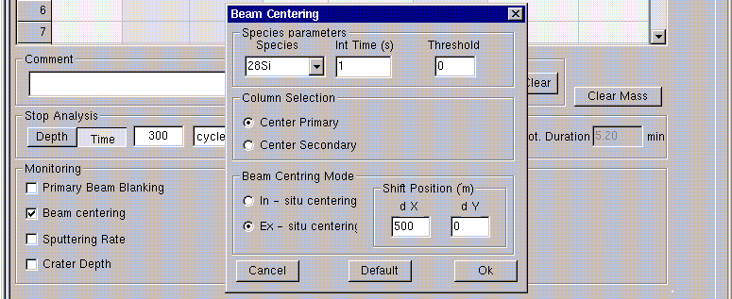

Procedure to define a Beam centering control

- Check the Beam centering option. The Beam centering dialog box opens.
- Select the reference species. Only the species defined in the species table with EM detector are available.
- Enter the integration time for the scanning image acquisition of the reference species by entering the Int. time value.
- Select the deflectors, primary or secondary, to be used for the beam correction: Primary beam centering or Secondary beam centering.
- Select the mode, in-situ or ex-situ, to be used for the beam correction: In-situ centering or Ex-situ centering.
- If the Ex-situ centering mode is chosen, define the point for performing the beam centering control, by giving the distance from the analysis position.
- At any time, the default values can be applied to the editing fields by clicking on the Default button. The previous values are erased.
- Close the Beam centering dialog box by clicking Close button. If the In-situ mode has been chosen, the additional sputtering time to execute the reference signal control is taken into account to compute the overall analysis time.
- If required, re-open the Beam centering dialog box by clicking right mouse button on the Beam centering label in the analysis definition window.

Routine for a Beam centering control

The stage should be moved to the analysis point, and the analysis started.
The beam centering control is performed before starting the normal acquisition.
If the Ex-situ mode has been selected, the stage is moved close to the analysis point, by a distance given by the operator.
If the analysis to be performed has the Dynamic Transfer (DTOS) On or an electronic gating, the DTOS is set Off and the electronic gate is set to 100% (no gating).
The magnet field starts cycling from the first mass, complying with the waiting times but not counting times on different species, until the reference species is reached.
A scanning image is acquired during the time defined by the operator (red frame in the Real Time Screen).
From this image: a) the center of the Field Aperture image is determined, 2) the values of ΔX and ΔY (in μm) which correspond to the distance from the center of the Field Aperture image to the center of the total image are computed, c) these values are converted to voltage values to be applied to the primary or secondary deflectors in order to get ΔX and ΔY equal to zero.
These voltage values are applied to the instrumentation.
If the analysis to be performed has the Dynamical Optical Transfer System On or an electronic gating, these parameters are set back to the instrument.
If the Ex-situ mode has been selected, the stage is moved back to the analysis point.
The acquisition starts in the normal way.
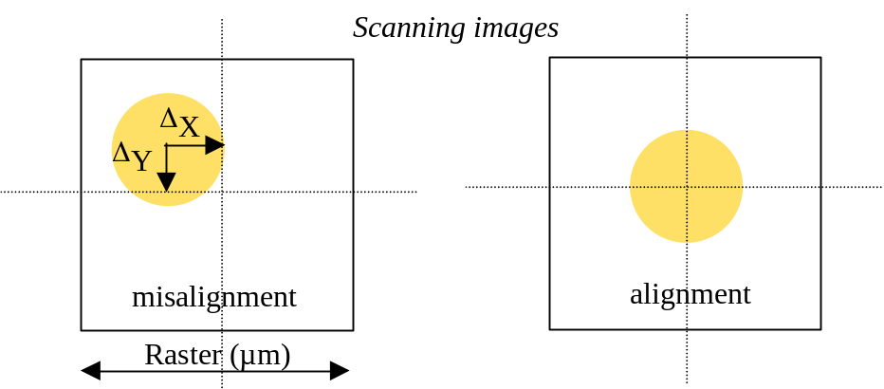

Error messages

  - If the intensity of the Field Aperture image is too weak, or the position of the Field Aperture image is outside of the total scanned image, the center of this image cannot be determined, and the message "Black image" appears. The beam centering control and the analysis associated to it are abandoned.
  - If the size of the Field Aperture image is too different from the expected size computed from the Raster, Max Area, and Field Aperture values, or if the Field Aperture image is not homogeneous enough, the message "Small raster" appears. The beam centering control and the analysis associated to it are abandoned. This is very much dependent of the tolerance value (in μm) which is set in the machine. In this case, the tolerance value must be increased in the Interface window of the computer (Tests of Beam centering > Set tolerance).
Contents ↑

Sputtering rate

Default status of this option: No

When this option is active (selected case), the sputtering rate will be changed at a given point(s) of the acquisition by applying either a new raster value or a different primary current preset. Up to 20 points for changing the sputtering conditions can be defined.

This option is useful for samples characterized by thin structures located below thicker layers. The analysis of these different types of layers can then be performed by sputtering fast over the first layers, and then slowing down when analyzing the thinner structures.

In order to define the change in the sputtering rate, the operator must define the following parameters:

- Mode: the change in sputtering rate can be performed at a given moment (Time). The Depth mode is not available for the IMS 7f and 4f-E7.
- New sputtering rate at: analysis time value for the change in sputtering rate.
- Method: to vary the sputtering rate either the primary intensity or the raster value are modified:
  - Raster: the operator enters a new raster value between 0 and 500μm. Note that if an electronic gating is applied during the analysis, its size is automatically adjusted to keep constant the analyzed area.
  - Primary intensity: the operator selects one of the primary beam presets available in the Tuning program.
- List: list containing the conditions for the changes in sputtering rate.
- Buttons or : are used to add or delete a line to the List.

Note: Only the parameters in the List, and not those currently selected in the other fields will be used for the Sputtering rate control.

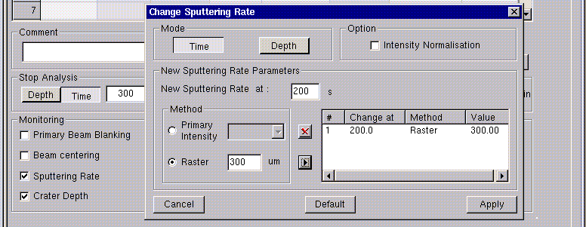

Procedure to define a Sputtering rate control

- Check the Sputtering rate option. The Sputtering rate dialog box opens.
- Enter the time value for the change in sputtering rate.
- Select one of the methods: Primary intensity or Raster.
- If the Primary intensity mode is chosen, select the primary beam preset to be applied.
- If the Raster mode is chosen, enter the new raster value to be applied.
- Add these parameters to the List by clicking the button.
- Add a second set of conditions for a change in sputtering rate to the List by repeating steps 2 to 6. Up to twenty set of conditions can be added in this way to the List.
- At any time, the default values parameters can be applied to the editing fields by clicking on the Default button. The previous values will be erased.
- Close the Sputtering rate dialog box by clicking Close button.
- If required, re-open the Sputtering rate dialog box by clicking right mouse button on the Sputtering rate label in the analysis definition window.
Contents ↑

Crater depth

This option is not available in the IMS 7f and 4f-E7.
Contents ↑

Reference signal

Default status of this option: No

When this option is active (selected case), the secondary ion intensity for one or several masses (up to 5) is measured periodically during the analysis or at the end of the analysis.

The reference signal intensities determined during the acquisition are displayed in the Analysis control window. These values are stored in the raw data file as reference points (refer to the § Curve Processing user's guide).
Before each reference point measurement, a mass calibration is performed to find the center of the mass peak for the reference species.

For a Reference signal measurement, the operator must define the following parameters:

- Reference species: it can be a symbol or a mass number, up to 5 species can be defined, they do not belong to the analysis species table.
- Measurement time: specific to each species. It corresponds to the integration time for the reference signal measurement.
- Detector: the detector can be selected among EM, FC, FC/EM, as for the masses in the species table.
- Reference species list: list containing the reference species and the corresponding measurement parameters (Measurement time, Detector).
- Buttons or : are used to add or delete a line to the Reference species list.
- Scan width: width of the mass scan (in number of ΔM intervals) around the mass peak center during the mass calibration routine. Default value: 2
- Scan #points: number of points to be scanned in each ΔM interval. Default value: 10
- Scan integration time (Time/Channel): integration time for each scan point. Default value: 0.16s
- Scan number of cycles: number of scans around the mass peak center before the peak centering. Default value: 2
- Last: if this option is checked the measurement of the reference signal is performed at the end of the analysis. The following parameters appear only if the option Last is not checked.
- 1st control: the number of the cycle for the first reference signal control. The control procedure is executed before this cycle.
- Period: the reference signal measurement will be performed each n cycles.
- Magnet cycle: number of cycles to be performed over the magnetic field values of the species table masses, after the Reference signal control has finished and before continuing the normal analysis. Default value: 0

Note: Only the parameters in the Reference species list, and not those currently in the Reference species, Measurement time and Detector, will be used for the Reference signal control.

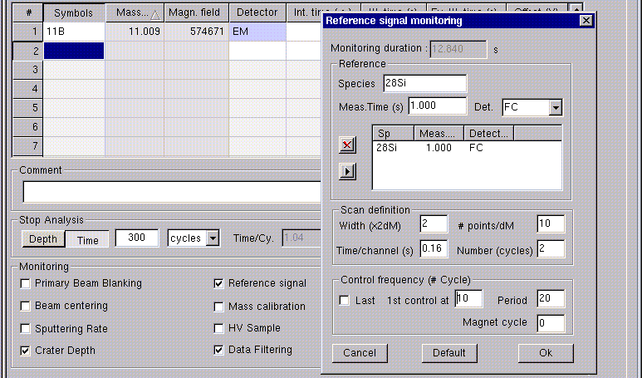

Procedure to define a Reference signal control

- Check the Reference signal option. The Reference signal dialog box opens.
- Enter either the mass number or the symbol of the reference species.
- Enter the integration time for this species.
- Select the secondary ion detector.
- Add this species and corresponding measurement parameters to the Reference species list by clicking the button.
- Add a second species to the Reference species list by repeating steps 2 to 5. Up to five species can be added in this way to the Reference species list.
- If required, modify the mass calibration Scan definition parameters.
- Select the frequency for the measurement of the reference signal(s) by checking Last, or else by entering the value of 1st control and Period. In this case, a Magnet cycle value can be entered if cycling over the analyzed species is requested.
- At any time, the default values for the Scan definition and Control frequency parameters can be applied to the editing fields by clicking on the Default button. The previous values are erased.
- Close the Reference signal dialog box by clicking Close button. The additional sputtering time to execute the reference signal control (displayed in the Monitoring duration field) is taken into account to compute the overall analysis time.
- If required, re-open the Reference signal dialog box by clicking right mouse button on the Reference signal label in the analysis definition window.

Routine for a Reference signal control performed periodically

The analysis starts.
When the cycle previous to the cycle selected to carry out the first reference signal control is completed, the magnet field cycling goes on, complying with the waiting times but not counting times on different species, until the reference mass is reached. An increasing order of magnetic field values is always kept, meaning that for an analysis over M₁, M₂, M₃ species, and if M₂ < M_{ref} < M₃, this corresponds to cycling over M₁, M₂, M_{ref}.
When set on the reference species M_{ref}, the magnet field is scanned around the field value given by the mass calibration B(M) table. The scanning is performed according to the scanning parameters defined by the operator in the Reference signal dialog box. A mass peak centering is then automatically performed.
The new magnetic field for M_{ref} is set on the machine, and the secondary intensity is measured over the time defined by the operator.
The magnetic field cycling re-starts until the end of the present cycle.
If the Magnet cycle parameter is non-null, a cycling over the masses defined in the species table is performed.
The analysis acquisition re-starts on the first species of the cycle number selected for the reference signal control.
The mass calibration will be controlled every n cycles following the same procedure.

Routine for a Reference signal control performed at the end of the analysis

The routine is identical, but after the measurement of the reference signal the analysis stops.
Contents ↑

Mass calibration control

Default status of this option: No

When this option is active (selected case), the mass calibration is automatically controlled during the acquisition and re-adjusted if a shift is detected.

The mass calibration control consists of recording a narrow mass spectrum centered onto the reference species (which belongs to the species table) and checking if the center of the peak still corresponds to the magnetic field value stored in the species table. If not, the new magnetic field value replaces the old one for the reference species, and for all other species the B field value is corrected with the relative variation found for the reference species:

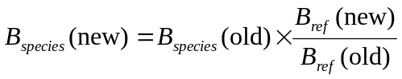

The B_{ref} (new) values determined during the acquisition are displayed in the Analysis control window. These values are also stored in the raw data file.

A mass calibration control can be combined with a sample HV control in the same analysis. In this case, the use of the same reference species is recommended.
Note: If both controls must be executed at the same cycle, the mass calibration is carried out first.

For a Mass calibration control, the operator must define the following parameters:

- Species: reference species, it must belong to the species table. The detector is the one defined for that species in the species table.
- Scan width: width of the mass scan (in number of ΔM intervals) around the reference mass peak center. Default value: 2
- Scan #points: number of points to be scanned in each ΔM interval. Default value: 10
- Scan integration time (Time/Channel): integration time for each scan point. Default value: 0.16s
- Scan number of cycles: number of scans around the mass peak center before the mass peak centering. Default value: 2
- 1st control: the number of the cycle for the first mass calibration control. The control procedure is executed at the beginning of this cycle.
- Period: the reference signal measurement will be performed each n cycles.

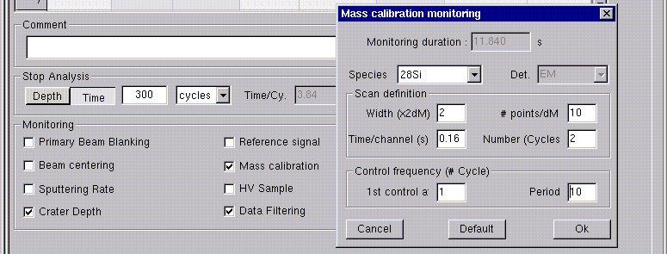

Procedure to define a Mass clibration control

- Check the Mass calibration option. The Mass calibration dialog box opens.
- Select the reference species. Only the species defined in the species table are available.
- If required, modify the mass calibration Scan definition parameters.
- Select the frequency for the measurement of the reference signal(s) by entering the value of 1st control and Period.
- At any time, the default values can be applied to the editing fields by clicking on the Default button. The previous values will be erased.
- Close the Mass calibration dialog box by clicking Close button. The additional sputtering time to execute the reference signal control (displayed in the Monitoring duration field) is taken into account to compute the overall analysis time.
- If required, re-open the Mass calibration dialog box by clicking right mouse button on the Mass calibration label in the analysis definition window.

Routine for a Mass calibration control

The analysis starts. When the cycle previous to the cycle selected to carry out the first mass calibration control is completed, the magnet field cycling goes on, complying with the waiting times but not counting times on different species, until the reference species is reached.
When set on the reference species, the magnet field is scanned around the B_{ref} field value, according to the scanning parameters defined by the operator in the Mass calibration dialog box. A mass peak centering is then automatically performed.
If a B_{ref} field shift is detected, the magnetic field value for every species is corrected according to the relationship given above.
The magnetic field cycling re-starts until the end of the present cycle. The analysis acquisition re-starts on the first species of the cycle number selected for the mass calibration control, with the new magnetic field values.
The mass calibration will be controlled every n cycles following the same procedure.

Contents ↑

HV sample control

Default status of this option: No

When this option is active (selected case), the centering of the energy distribution of a reference species in the energy slit is automatically controlled. If, due to a charging effect, an energy distribution shift compared to the initial setting is detected, a voltage offset is applied on the sample holder in order to compensate the shift. This offset is permanently applied to measure every species until the next HV sample control is done.

The offset values determined during the acquisition are displayed in the Analysis control window. These values are also stored in the raw data file.

A mass calibration control can be combined with a HV sample control in the same analysis. In this case, the use of the same reference species is recommended.
Note: If both controls must be executed at the same cycle, the mass calibration is carried out first.

For a HV sample control, the operator must define the following parameters:

- Species: reference species, it must belong to the analysis species table. The detector is the one defined for that species in the species table.
- Integration time: counting time per data point to record the energy distribution. Default value: 0.1s
- Offset min: low limit of the offset range to be scanned in order to record the energy distribution.*
- Offset max: high limit of the offset range to be scanned in order to record the energy distribution.*
- Step: the offset step to record the energy distribution. Default value: 1
- Energy pass band (E_{w}): energy slit width of the mass spectrometer. This value is taken from the OIP Energy slit width parameter (Mass resolution dialog box), it cannot be modified in the HV sample dialog box.
- Energy gap (E_{gap}): it is the gap left between the beginning of the energy distribution and the low energy side of the energy slit. This value is read from the OIP Energy slit shift parameter, it cannot be modified in the HV sample dialog box.

*The values of Offset min and Offset max are limited to the following values (these correspond also to the default values):

 | From | To
Sec. Polarity > 0 | 1.2 * Energy pass band | -0.2 * Energy pass band
Sec. Polarity < 0 | -1.2 * Energy pass band | 0.2 * Energy pass band

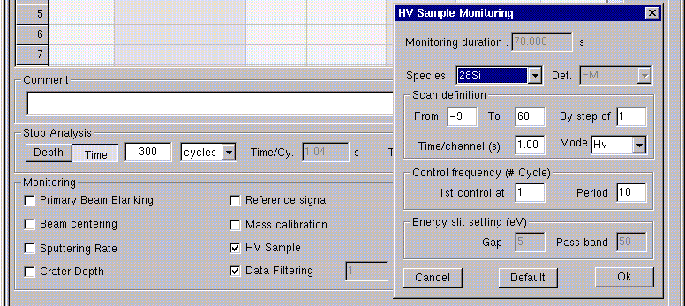

Procedure to define a HV sample control

- Check the HV sample option. The HV sample dialog box opens.
- Select the reference species. Only the species defined in the species table are available.
- If required, modify the value of the Integration time.
- If required, modify the scan parameters Offset min, Offset max, Step.
- Select the frequency for the measurement of the reference signal(s) by entering the value of 1st control and Period.
- At any time, the default values can be applied to the editing fields by clicking on the Default button. The previous values are erased.
- Close the HV sample dialog box by clicking Close button. The additional sputtering time to execute the reference signal control (displayed in the Monitoring duration field) is taken into account to compute the overall analysis time.
- If required, re-open the HV sample dialog box by clicking right mouse button on the HV sample label in the analysis definition window.

Routine for a HV sample control

The routine for the energy distribution centering is illustrated in the figure below. The curve represents the position of the secondary ion distribution in the energy slit plane for different HV sample offset values.

The analysis starts. When the cycle previous to the cycle selected to carry out the first HV sample control is completed, the magnet field cycling goes on, complying with the waiting times but not counting times on different species, until the reference species is reached.
When set on the reference species, the sample offset is scanned from the low limit to the high limit entered by the operator. For the scan, the offset is added to any offset value already applied using the Tuning program.
The program determines the offset value corresponding to the maximum of the energy distribution, and then the offset value V_{5%} yielding to 5% of the maximum intensity measured towards the low energy side of the energy distribution. The new HV sample offset value applied to go on the analysis is computed with the relationship:

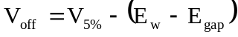 for positive secondary ion analysis

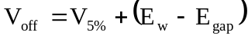 for negative secondary ion analysis

The HV sample value will be controlled every N cycles following the same procedure.

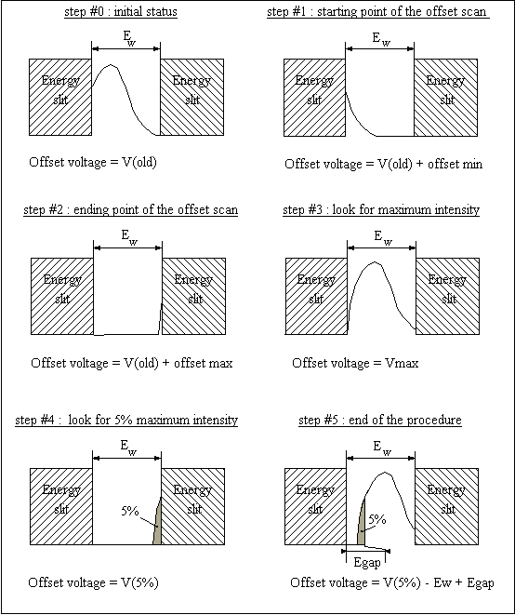
Routine for the energy distribution centering

The illustration above shows in step#0 the status of the energy distribution centering before the HV sample control. It is not correct because the low energy side of the energy distribution is stopped by the low energy edge of the energy slit.
The illustrations in step#1 and step#2 correspond to an analysis of positive secondary ion analysis. In case of negative secondary ion analysis, the offset would be equal to V(old) + Offset max and V(old) + Offset min in step #1 and step #2 respectively.

Contents ↑

Data filtering

Default status of this option: Yes
Default mode: 1cycle/data point

This function deals with the filtering of data. By default, a data point corresponds to one cycle, the number of frames corresponding to a cycle being defined by the Integration time in the species table.
The other options are not available yet.

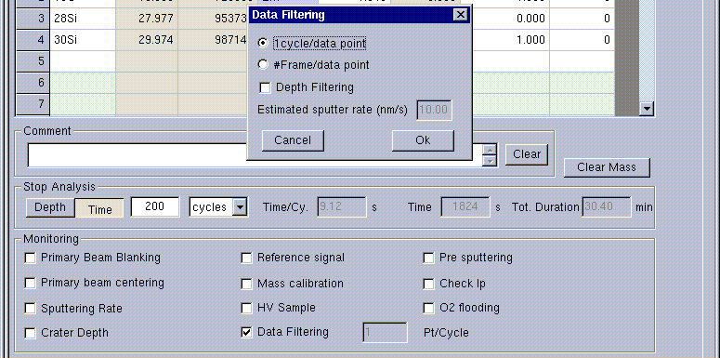

Contents ↑

Pre-sputtering

Default status of this option: No
Maximum value of the pre-sputtering: 999s

When this option is active (selected case), the sample is sputtered for a time entered by the operator before acquiring the data. At the end of the pre-sputtering time, the analysis starts automatically.

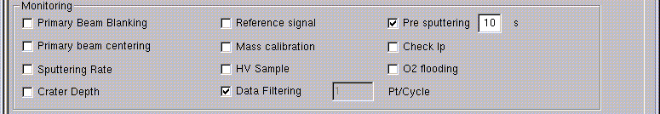

Procedure to run an analysis using the Pre-sputtering option

- Check the Pre-sputtering option.
- Enter the time (in seconds) for the pre-sputtering.
Contents ↑

Check Ip

Default status of this option: No

When this option is active (selected case), the value of the primary current is automatically controlled at the beginning of the acquisition (during 5s). If the value is outside the interval defined by the operator, a warning prompt is displayed and the analysis does not start.

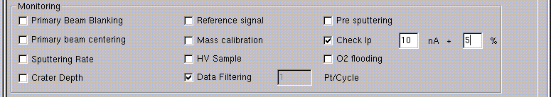

Procedure to run an analysis using the Check Ip option

- Check the Check Ip option.
- Enter the values of the Ip and the accepted percentage of deviation from that value.

Example: Let us assume Check Ip parameters 10nA ± 5%. The analysis will start only if the value of the primary current is between 9.5 and 10.5 nA.
Contents ↑

O2 flooding

Not available yet.
Contents ↑

First point X/Y, Last point X/Y, Steps number

These measurement conditions parameters are available for the Linescan analyses only.

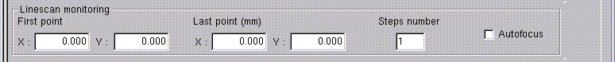

- First point X/Y editing fields: coordinates X and Y (in mm) defining the first point of analysis.
- Last point X/Y editing fields: coordinates X and Y (in mm) defining the last point of analysis.
- Steps number editing field: number of steps to perform between the first and the last point.
- Autofocus check box: not available for the IMS 7f and 4f-E7.

During a Linescan analysis, the sample stage is moved in both X and Y directions according to the previous parameters. On each analysis point, one cycle is carried out to measure the secondary ion intensity for all species defined in the species table.

The total duration of the Linescan analysis is fixed by the number of steps and by the duration of each cycle.
Contents ↑

Image mode, Spatial resolution

The Image mode selection is available for the Image analyses only.
Select either scanning to acquire scanning ion images, or CCD to acquire direct ion images using the microchannel plate detector (connected to a CCD camera), or RAE to acquire direct ion images using the RAE detector (if available in the instrument).

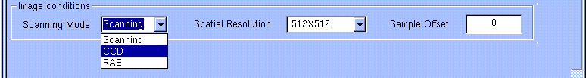

Select the spatial resolution for the saving of the acquired images in the Spatial resolution scrolling menu. Different resolutions are available depending on the selected Image mode.

Contents ↑

Energy mode

The Energy mode selection is available for the Energy analyses only.
Select either HV to apply a sample offset by varying directly the sample extraction high voltage, or E.S.A. to apply a sample offset by changing the main electrostatic sector value.

- Default value: HV

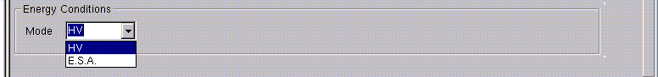

Contents ↑

dM mass step

This field is available for the Mass spectrum type of analyses only.

- Default value: 0.1, minimum value: 0.001, maximum value: 0.5

It is the value of constant mass step used to record every elementary mass spectrum over the mass range for Mass spectrum.

Note: This parameter appears only if the DM cte mode is selected. In this mode, the mass spectrum is recorded at constant mass step.

Contents ↑

Nb of data points / ΔM

This field is available for the mass spectra type of analyses only (Mass spectrum, Bargraph, High resolution).

- Default value: 9, minimum value: 1, maximum value: 21

It is the number of points measured per peak width ΔM. This value is required to compute, according to the mass resolution value entered in the OIP parameters, the B field step used to record every elementary mass spectrum over each mass range for Mass spectrum, Bargraph, and High resolution analyses.

Note: For the Mass spectrum analyses, this parameter appears only if the MR cte mode is selected. In this mode, the mass spectrum is recorded at a constant number of steps per peak width ΔM.

Example: For the peak ³⁰Si, a mass resolution of 600 and a number of data points / ΔM, of 9:
peak width = 30/600 = 0.05 a.m.u.
mass step = (0.05 / 9)
Contents ↑

Number of ΔM

This field is available for the Bargraph type of analyses only.

- Default value: 1, minimum value: 1, maximum value: 21

This value defines the width of every mass scan carried out, centered on every integer mass value included in the mass ranges defined in the species table. This value is entered in number of 2 peak widths ΔM (one to the left and the other to the right of the integer mass). The peak width ΔM is fixed by the mass resolution value entered in the OIP parameters, since it is equal to the mass M divided by the mass resolution MRP.

Example: For the peak ³⁰Si, a mass resolution of 600 and a peak scan width = 2 (×2ΔM)
peak width = 30/600 = 0.05 a.m.u.
Integer mass: 30 a.m.u.
Mass scan range: [29.9;30.1]
Contents ↑

Pre-cycle

This field is available for the mass spectra type of analyses only (Mass spectrum, Bargraph, High resolution), if more than one cycle is defined for the analysis.

- Default value: 0

This value defines the number of cycles to be performed over the low and high masses of the mass ranges defined in the species table before starting the analysis.

Contents ↑

The main Analysis window in acquisition mode

An analysis acquisition window is activated from the definition window after defining a new analysis, by clicking the Go analysis button or by selecting the Go function in the Analysis menu.
When an analysis acquisition window is activated, the main Analysis window gives access to the following menus:
- File
- View
- Analysis
- Option
- Window
- Help

A Toolbar can also be displayed if this option is checked in the View menu. It gives access to the most common functions.

File menu

In the File menu, the following functions are available:
- New: allows to create a new analysis definition window of a given analysis type. The New analysis dialog box opens.
- Open: allows to load a stored definition file of any analysis type. The Open dialog box opens.
- Close: closes the activated analysis acquisition window.
- Save: saves the raw data displayed in the activated acquisition window.
- Save as: it allows to save the raw data displayed in the activated acquisition window under any file name. Not available yet during the acquisition (refer to § Saving a raw data file).
- Print: allows to print out the curves displayed in the analysis acquisition window.
- Print preview: shows a preview of the printed paper output.
- Print setup: gives access to the printing options. For the postscript printer two output formats are possible: landscape and portrait.
- List of the four last saved definition file names.
- Exit: quits the Analysis program.

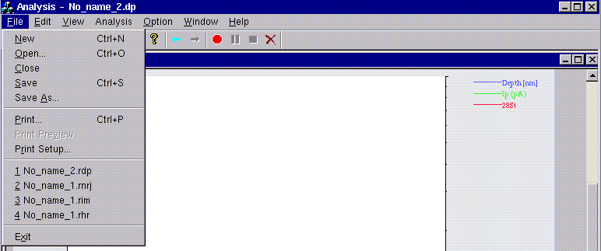

View menu

In the View menu, the operator can check/uncheck the Toolbar, Status bar options. If checked, the Toolbar, Status Bar will be shown.
Contents ↑
Analysis menu

In the Analysis menu, the operator has access to the Start, Pause, Abort, Stop analysis functions.

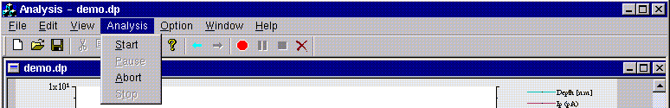

Contents ↑
Option menu

In the Option menu, the operator can select different options:
- Ip: by selecting this option, the primary current is also displayed in the acquisition window. Note that this option modifies the display only, the Ip curve (a Ip data point is measured for each secondary intensity data point) being always recorded and saved with the raw data.
- Cursor: by selecting this option, a cross cursor appears on the graphic area. It allows to read the X and Y coordinates of any point on the graph. These coordinates are displayed on the footer of the acquisition window (Status bar).
- Control: by selecting this option the Analysis control window opens on the left of the Analysis main window. This window automatically appears during an acquisition whenever one of the followings monitoring controls is performed during the acquisition: Mass calibration, Reference signal, or HV sample.
- Refresh curve config: the display conditions can be modified in the Curve setup program (color of the lines, symbols,…). Whenever these settings are modified in the Curve setup, they can be updated in the acquisition graphic display by selecting this function. The parameters are updated in any case when the Analysis program is launched.
- Ascii: by selecting this option, an Ascii file is saved together with the binary file at the end of the acquisition.

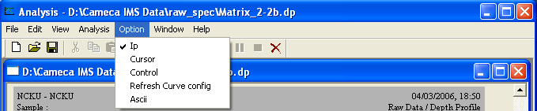

Contents ↑
Window menu

In the Window menu, the operator can arrange the different analysis windows in one of the following modes: New window / Cascade / Tile / Arrange icons.
The operator can also have access to any of the opened windows (analysis definition as well as analysis acquisition windows).
Contents ↑
Toolbar

The toolbar contains buttons giving a quick access to several functions. By placing the cursor on a button, its function is automatically displayed.
Some functions are available only in definition mode, others only in acquisition mode.

From left to right, the buttons correspond to the following actions:
- New: opens a new analysis definition window.
- Open: loads a previously stored analysis definition file.
- Save / Save as: saves the raw data file corresponding to the current acquisition (refer to § Saving a raw data file).
- Cut / Copy / Paste: not available yet.
- Print: prints out the curves displayed in the current analysis acquisition window.
- Help: not available yet.
- Go to definition mode: allows to go back to the definition window, available in acquisition mode only. If it is used during the analysis, all parameters in the definition window are grayed and cannot be modified.
- Go analysis: available in the definition mode only.
- Start: starts the analysis.
- Pause: the analysis is paused.
- Stop: stops the analysis and saves data.
- Abort: aborts the analysis without saving data.
Contents ↑

Acquisition window

The analysis acquisition window contains:
- Top region: display of the analytical parameters,
- Middle region: graphic window used to display the curves of secondary ion intensity (c/s) vs. acquisition time, mass or energy.
- Bottom region: buttons and editing fields to modify the display parameters of the current analysis, and editing fields to modify the total acquisition time of the current analysis.

An example of acquisition window is shown below.

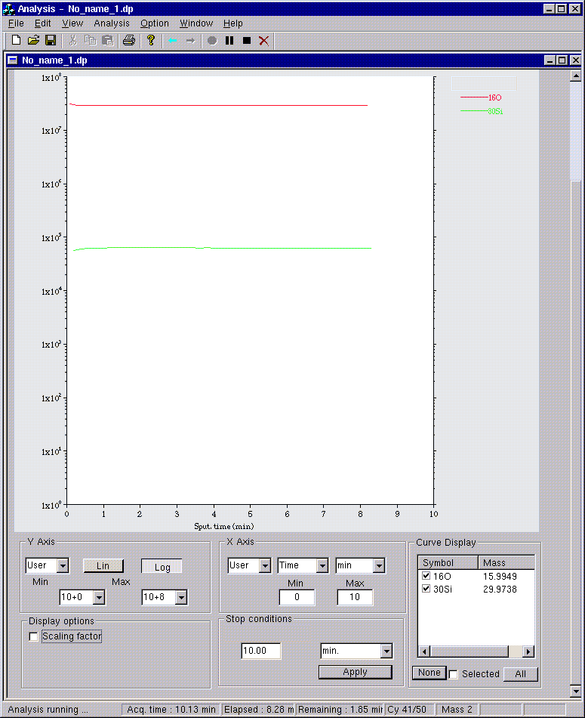

Note: For Image type of analyses, the graphic region is different from the one described below (refer to the § Graphic display for the Image acquisition section).
Contents ↑

Starting an analysis

This function Start starts a new analysis, to be run with the measurement conditions defined in the analysis definition window.

When the analysis starts, the Stop, Abort, Pause buttons become available.

During the analysis, messages are displayed in the footer of the acquisition box.
- Analysis status: Loading OIP (Beam Off), Primary beam intensity measurement (Beam Off) or Running (Beam On),
- The current analyzed species: by numerical order as they appear in the species table,
- The present cycle of the analysis,
- The elapsed time and the remaining time of the analysis.
Note: The analysis time corresponds to effective sputtering time (Beam On). The total duration of the analysis can be larger, for example, if the beam blanking option is selected.

Procedure to start a new analysis

- Click Analysis icon in the main icon board. The Analysis program opens with a definition window of Depth profile type.
- If required, open a new window by clicking New button in the main window Toolbar or select the New function in the main window File menu. The New analysis dialog box opens.
- Select the analysis type, and check the status of the Keep last ISF and Keep mass species options.
- Click OK button. A new analysis definition window of the requested analysis type is opened.
- Define new measurement conditions (see previous section).
- Click Go analysis button to open the corresponding acquisition window. The program checks the coherency of the entered parameters. If mismatching parameter values are detected, there is a prompt asking for correction(s).
- Click the red Start button.
- The OIP parameters defined in the definition window are loaded to the instrument.
- The primary beam is switched Off to measure the primary beam intensity, then switched On to start the acquisition.

Procedure to re-start the same analysis

- Click the red Start button.
- The OIP parameters defined in the definition window are loaded to the instrument.
- The primary beam is switched Off to measure the primary beam intensity, then switched On to start the acquisition.

Procedure to re-start the same analysis but with different measurements conditions

- Click the Go to definition button in the Toolbar to return to the analysis definition window corresponding to the current analysis. The analysis definition window is opened.
- Modify the measurement conditions. If required, save the new analysis definition file.
- Click Go analysis button to open the corresponding acquisition window. The program checks the coherency of the entered parameters. If mismatching parameter values are detected, there is a prompt asking for correction(s).
- Click the red Start button.
- The OIP parameters defined in the definition window are loaded to the instrument.
- The primary beam is switched Off to measure the primary beam intensity, then switched On to start the acquisition.
Contents ↑

Stopping the acquisition and saving raw data

The acquisition stops, either by clicking the Stop button, or when the acquisition time finishes.

The Stop command is applied either at the end of the cycle being recorded (for Depth profile, Image analyses), or immediately for the mass spectrum type of analyses.

The Stop procedure consists of:
- Switching off the primary beam,
- Measuring the primary beam intensity,
- Opening of the Save as dialog box asking the operator the file name to save data on the disk.

Note: in version 2.1, it is possible to enter the raw data file name by calling the Save or Save as functions during the acquisition. In this case, at the end of the acquisition, the file is automatically saved under the name given by the operator.

In the Save as dialog box, the file name must be entered and the saving confirmed by clicking the Ok button. The new data file is then saved on the disk.

Note: If the file name entered by the operator already exists, a prompt appears asking for the confirmation to overwrite the existing file.

Filename

The name of the raw data file consists of two parts: filename.analysis_type_extension.
The new file name must be entered without extension. The extension is automatically added to the filename by the program, according to the analysis type which was run.

The different analysis type extensions are reported in the following table:

Analysis | Analysis type extension
Depth profile | .dp
Mass spectrum | .ms
Bargraph | .br
High resolution | .hr
Energy | .nrj
Linescan | .ls
Image | .im

At the end of the analysis, the target file contains both secondary ion intensities and experimental conditions.
Contents ↑

Pause function

This function interrupts immediately the current analysis:
- The primary beam is switched Off,
- The clock measuring the sputtering time stops.
Contents ↑

Abort function

This function aborts immediately the present analysis. Acquired data are not saved on the disk.
Contents ↑

X and Y axis display parameters

Auto/User

For the X and Y axis, the operator can select using scrolling menus between:
- the Auto mode: executes an auto-scale of the X / Y axis
- the User mode: the scale is set to the previous scale defined by the operator in the User mode. If this function is used for the first time after opening the Analysis program, the default values are 10E+0 and 10E+6. The operator can manually adjust the low (Min) and high (Max) limits of the X and Y axes of the graph of the present analysis.
Contents ↑

Lin/Log

Two buttons Lin and Log toggle from linear to logarithmic scale for Y scale.
Contents ↑

X axis units

- Editing field: is used to enter the new value of the analysis time.
- Scrolling menu: units of the X axis
  - Cycles, Seconds, or Minutes
Contents ↑

Curve display

The Curve display table lists the displayed curves, each curve being identified by the corresponding symbol and nominal mass. A check box exist for each curve, which allows to display or not a given curve in the graphic window.
Buttons None and All allow to display no curves or all curves respectively.

Note: The display state is independent of the curves recording. The curves which are not displayed are saved, of course, in the raw data file.
Contents ↑

Display options

The Scaling factor check box applies a multiplying constant factor to all the displayed curves. This scaling factor is used for display only, it does not change the raw data which are stored on the disk.

Curve color, symbols

The display setting of the curves cannot be directly modified in the Analysis program, the Curve setup program allows to set the color of the lines, symbols,… for each curve. Whenever these settings are modified in the Curve setup, they can be updated in the acquisition graphic display by selecting the Refresh curve config function in the Option menu. The parameters are updated in any case when the Analysis program is launched.

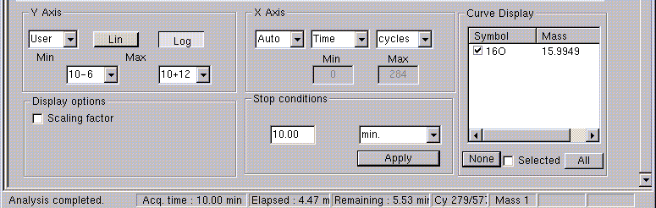

Display of mass ranges for Mass spectrum, Bargraph, High resolution analyses

For the Mass spectrum, Bargraph, High resolution analyses, only mass range is displayed at a time on the graphic window. In order to change from one mass range to the next mass range, to go to the first mass range, or to the last mass range, the following buttons are available.

Contents ↑

Stop conditions

Before starting the acquisition or during the acquisition, the operator can change the analysis stop conditions.
Enter either the number of cycles of the analysis or the analysis duration (in seconds or minutes). Hit reurn key in keyboard or click Apply button on the Analysis window to validate the new value.
The units can be changed using the scrolling menu next to the editing field.

Note 1: the acquisition time can be modified as many times as required.
Note 2: if the analysis should be stopped immediately, use the Stop function.

Display of the analytical parameters

On the top of the window, the analytical parameters are displayed: Source, Impact energy, Primary current (initial value/final value), Raster value, DTOS state, Gate, Analysis chamber pressure, Sample HV, Mass resolution, FA diameter, CA diameter, Energy slit width.
Also, the Matrix, Sample names are displayed, they are read from the Navigator program at the beginning of the acquisition.
Additional information such as Recipe (definition) filename, Data (acquisition) filename, type of analysis, data and time are also given.

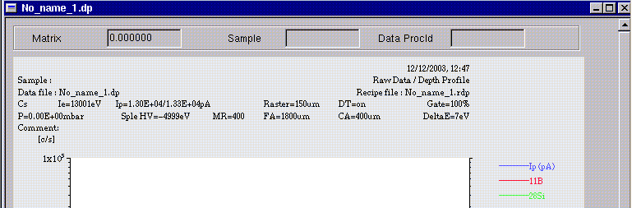

Contents ↑

Analysis control window

This window is used to display the results in case of Reference signal, Mass calibration and HV sample controls.
For each type of control, an item list is available. The values (secondary ion intensities for Reference signal control, B field values for Mass calibration control, offset values for the HV sample control) determined after each control procedure are displayed in the list.
In order to select the list corresponding to each type of control, click on the corresponding thumb-index on the top of this window.

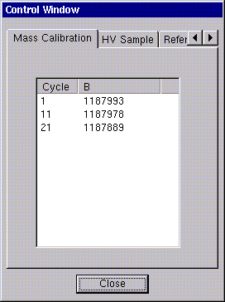

Note: the Analysis control window is automatically opened at the beginning of the acquisition and automatically closed at the end of the acquisition, when the analysis includes at least one of the controls: Reference signal, Mass calibration or HV sample.
Contents ↑

Graphic display for the Image acquisition

This window contains a grid which is automatically adjusted according to the number of species to be analyzed.

The displayed color scale is related to the image surrounded with a red frame. In order to display the color scale of a given image, click the image of interest. The default values for the low and high limits of the color scale of each image are the minimum and maximum count number per pixel measured in the image.

Images are displayed sequentially for every cycle. It means that, first of all, the first image of the first cycle is displayed, then the second image of the first cycle, and so on until the end of the first cycle.

At the beginning of the second cycle, the image of the first species recorded during the first cycle is replaced by the second image of the first species recorded during the second cycle.

The Color scale functions allow:
- to show the image in Inverse video mode if this button is clicked,
- to select the look-up table (LUT)

Two buttons Auto and User allows to change from auto-scale mode to user mode. If the User mode is selected, the operator can adjust the low and high limits of the color scale. The color scale limits are adjusted independently for every image, whereas the LUT is common to all images.

The Pages navigator functions allow:
- if the button Image is selected, the arrows allow to switch from one image to the next image, or from the first image to the last image.
- if the button Page is selected, the arrows allow to switch from one page to the next page, or from the first page to the last page. When the number of images cannot be contained in one page, an additional page is created.
- Buttons 1, 6, 25 are used to change the number of images or pages (depending on which button Image or Page is selected) which can be displayed in the graphic window. The size of the image is of course smaller when 25 is selected.

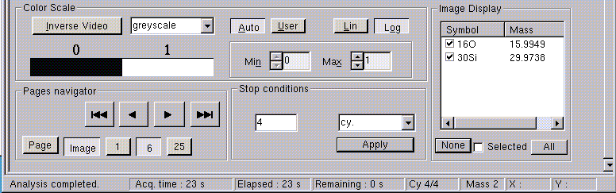

Contents ↑

Alignments

This chapter are dedicated to typical methods of analysis. Due to the high flexibility of the instrument, it is not possible here to describe all types of conditions required by all types of samples; however, the most commonly used are reviewed.

For each of these typical analyses, the specific alignment procedure (if any) is explained together with analytical conditions and results. These include:

n Depth profiles in large areas with low MRP, energy filter and high MRP;
n Small area depth profiles;
n Energy distribution.

A higher variety of analysis can be obtained by adding several of the alignment procedures described here.
Contents ↑

Depth profile

Low MRP ⎯ Large area profile

CONDITIONS

q If the mass resolution required by the analysis is low (MRP ≤ 1000) even FA No. 1 can be used for aperture aberration considerations. The dimensions of the FA will be selected in order to obtain the appropriate analyzed area and is not implied by aperture aberration considerations.

q If the area of interest is large, the analysis does not require a good lateral resolution of the microscope and even the largest contrast aperture can be used in order to increase the transmission.

q In order to minimize the crater edge effects the analyzed area must be smaller than the crater size.

n Typical conditions used for this purpose are 250 x 250 µm raster and 60µm analyzed area. If a 500 x 500 µm is used the diameter of the analyzed area can be made larger (e.g.: 150µm).

n Of course it is possible to use a 150µm analyzed area with a raster of 250 x 250 µm but the crater edge effects will be more severe. The two major parameters influencing the crater edge effects are:

⎯ The flatness of the crater bottom. Using an optical gate, the flat portion of the crater is approximately equal to the raster size minus one beam diameter. This gives the maximum size of the analyzed area.
⎯ The lateral resolution of the microscope. If the element of interest is highly concentrated at or near the surface, when the deepest layers are viewed there is still a high concentration of that element surrounding the analyzed area. When high dynamic range is required, there is a possible contribution of these ions through the field aperture.

q Typical conditions used for this type of analysis are:

n Primary ions:

⎯ Raster 250 x 250 µm;
⎯ The intensity (and therefore the beam diameter) is adjusted in order to get the appropriate sputtering rate;
⎯ Focused beam.

n Secondary ions:

⎯ Transfer lens 150µm;
⎯ CA 400 µm (or smaller if too much signal on EM);
⎯ FA No. 2 for an analyzed area of 60 µm in diameter;
⎯ Energy slit centered and wide open.
Contents ↑

ALIGNMENT

Starting from the basic alignment described in § Primary Ion Optics and § Secondary Ion Optics documents, the following adjustments have to be performed:

q Primary column:

n use appropriate beam intensity (Lprim3);

n check focusing of primary beam (Lprim4);

n center the beam in front of the analyzed area (without raster).

q Secondary column:

n select the appropriate contrast aperture. Center the contrast aperture to have the best image sharpness (performed on a grid test sample)

n use the three slits (entrance, energy, exit) wide open;

n FA No. 2 is generally used for a 250 x 250 µm raster.
Contents ↑

Energy filter ⎯ Large area profile

CONDITIONS

A typical secondary ion mass spectrum contains, in addition to the analytically useful atomic ions, numerous peaks due to the molecular ion species proceeding from the sample matrix atoms, the primary bombarding ions and/or residual vacuum species. Although the intensity of these interfering ions decreases significantly as the complexity of the molecule increases (i.e., the number of atoms in the complex), they can still be sufficiently intense to produce a measurable background signal especially when trying to analyze at very low dopant concentrations.

This situation will lead to a background limited rather than a signal limited detectability.

The analysis of Arsenic in silicon provides a good example of this interference situation. Oxygen bombardment of silicon produces a molecular ion at mass 75, (29Si 30Si 16O)+ with an intensity equal to an Arsenic concentration of about 1 x 1020 at/cm3. The detection limits can be significantly lowered by using the energy filtering technique.

This technique uses the fact that atomic and molecular ions of the same nominal mass have different initial kinetic energy distributions as shown in figure below.

Those graphs are obtained by adjusting and closing the energy slit in order to keep a gap of a few eV. The specific program of the computer then executes a progressive shift of the secondary ions accelerating voltage in order to pass the ions through the slit with increasing initial energy.

For maximum sensitivity, the mass spectrometer would normally be tuned to accept ions with energies around the peak in the energy distribution. However, since the atomic and molecular species have both peaks at the same energy, they are detected with equal facility under these instrumental conditions. If the energy spectrum is shifted by offsetting the sample voltage so as to accept only ions whose energies lie on the high-energy tail of the distribution, the mass spectrometer will selectively discriminate against the interfering molecular ion. This operational mode will reduce molecular ions by several orders of magnitude with only a relatively small reduction in the atomic ion intensity. This procedure has the additional analytical advantage in that it can be rapidly computer controlled. The operating mode is as follows:

(See figure below)

- Energy slit wide open.
- Translate the slit outside of the optical axis in order to obtain the maximum intensity.
- Put an offset of -50 to -70 V (for the interference 75As+ / 75Si2O+) on the secondary ion accelerating voltage using the § Tuning program.

If we now examine the As in Si case, the figure below shows that a 60 V offset results in a much more important decrease of the molecular ion signal when compared to the decrease of As signal. This technique allows to greatly improve the signal to background ratio at the expense of some absolute signal intensity.

The sample voltage offset is thus commonly used for known molecular ion situation. In an uncharacterized materials system, there are always suspected molecular ion interference problems which are not known in priority. In these cases, this technique is used to evaluate the ion “purity” at the mass of interest. Thus a given mass can be monitored with and without voltage offset. If there is little or no interference at that mass, the two ion intensity measurements will be nearly equal. If there is a relatively intense molecular ion present, the two measurements will differ markedly. Thus, the voltage offset capability can provide an indication of contamination (when present) as well as improve limits of detection in a molecular interference situation.

This approach will be successful provided that the energy distributions of the atomic and molecular ions are appreciably different. There are some cases, however, in which the distributions are very similar. In those cases, the sample voltage offset does not solve the interference problem and one must try some other approach, such as a high mass resolution.

Contents ↑

ALIGNMENT

The alignment is the same as that for low MRP profile, except for the position of the energy slit. In order to get the position of the slit as shown on figure below, proceed as follows:

q Check that no offset is applied on the sample voltage;

q Fully open the energy slit (item 1);

q Looking at the intensity (or image) of a matrix peak, translate the slit outside of the optical axis up to the position where the signal starts decreasing.
This decrease indicates that the inner side of the slit starts cutting the beginning of the energy distribution (item 2);

q In the Analysis program, introduce a voltage offset (item 3). Refer to § Offset.

Contents ↑

High MRP ⎯ Large area profile

CONDITIONS

q If the mass resolution required by the analysis is high (MRP > 1000), the FA No. 2 or smaller has to be used to reduce the crossover aberrations. This allows also to minimize the crater edge effects.

q If the area of interest is large, the analysis does not require a good lateral resolution of the microscope and even the largest contrast aperture can be used in order to increase the transmission. Keeping a good transmission is particularly important for high MRP conditions. The largest CA (400 µm) is generally used.

q In order to decrease the shoulders appearing on the side of the mass peak, an energy gap of ≈ 50 eV or lower must be used. These shoulders are several orders of magnitude below the maximum intensity. They do not affect MRP measured at 10% but affect the analytical mass discrimination. Reducing the energy slit width reduces these aberrations.

q Transfer optics: The zoom must be adjusted in order to prevent crater edge effects. The relation between the rastered area and the analyzed area affects the dynamic range of the profile. With a raster of 250 x 250µm the area can be adjusted up to ≈150 µm, provided that this area is well centered on the crater and the primary beam is small enough (the flat part of the crater is the raster size minus one beam diameter).

q Typical conditions:

n Primary ions:

⎯ Raster 250 or 500 µm;
⎯ Beam diameter 10 or 50-60 µm;
⎯ Focused beam.

n Secondary ions:

⎯ Transfer lens: 25µm for a 10µm beam
150 µm for a 50-60 µm beam
⎯ Contrast aperture 400 µm;
⎯ Entrance slit width adjusted for required MRP;
⎯ FA No. 2 or smaller;
⎯ Energy slit width 50 eV (1 turn) or smaller.
Contents ↑

ALIGNMENT

Starting from the alignment described in § Primary Ion Optics and § Secondary Ion Optics, proceed as follows:

q Select the desired transfer lens zoom.

q Switch to 400 µm CA and center it.

q Switch to FA No. 2 (or smaller) and center the FA on point 0 of the α, β aberrations (when decreasing/increasing the mass the image should disappear on the center of the FA image).

q Switch to slit mode and:

n check focus of projector lens (sharp image of the exit slit);
n close entrance slit for the desired mass resolution, and center it on the CA image;
n improve the image of the entrance slit by:

⎯ moving the FA position slightly in X-Y (should already be very close to point 0);
⎯ close the energy slit (1-turn opening or less) and translate;
⎯ adjust the stigmator effect (Quad of LPR1-LPR2).

n close exit slit to the desired width (it should be two times larger than the entrance slit);
n adjust parallelism between the entrance and exit slits with the stigmator (Stig. of LPR1-LPR2).

q Return to image mode, center the secondary beam in front of FA (use primary beam position deflector).

Note: The alignment for obtaining high MRP conditions can also be performed by using the dynamic transfer system, which allows to minimize the aperture aberrations and to increase the transmission. However, this type of alignment gives in general worse reproducibility results.

Contents ↑

Small area depth profile

CONDITIONS

When a small area profile has to be performed (e.g.: 5 x 5 µm) the IMS6F will give a better sensitivity if used as a microprobe. If the secondary ion optics operates as a microscope, the lateral resolution might not be good enough for the analysis. The lateral resolution requested by the sample is obtained by means of a small primary beam diameter (e.g.: 1 µm) and the use of the scanning ion image system with the Dynamic Transfer System On.

Therefore, typical conditions are:

q Primary ions:

n Beam diameter adjusted for the desired lateral resolution;
n Raster size = analyzed area plus at least two beam diameters.

q Secondary ions:

n Use of the dynamic transfer system for minimum aperture aberrations if mass resolution is of concern;
n 25 µm transfer lens;
n Largest CA (400 µm);
n FA No.2 is generally used but the analyzed area is determined by the electronic gate.

Contents ↑

ALIGNMENT

q Follow the same procedure as for large area analysis (low MRP, high MRP). The energy filter technique will not be used for small area analysis. Thanks to the 25 µm transfer lens together with the dynamic transfer system the IMS system gives directly high MRP without significant loss in transmission. Also, the high MRP analysis gives better sensitivity than the energy filter technique when a molecular species have to be discriminated.

q The additional problem is related to the exact positioning of the analyzed area. This can be done by different means:

n Scanning ion image ⎯ If the area to be analyzed can be viewed looking at the scanning ion image, this allows direct positioning of the electronic gate. For example, a silicon transistor surrounded by a Si3N4 layer is easily observed looking at the SiN- image (Cs bombardment). The positioning must be done in the Analysis program after calibration of the magnetic field. In order not to sputter the sample too much before starting the analysis:

⎯ use a larger raster size for prepositioning, or
⎯ use a lower primary beam intensity (make sure that the beam does not move when changing the intensity).

n Image processing ⎯ It is advised not to use an electronic gate and to save the whole scanning image. The selection of the area of interest will be software selected using the Image processing program.
Contents ↑

RESULT

The figure below shows an example of small area, high MRP depth profile. The SiO2 layer surrounding the transistor allows area location and electronic gate positioning looking at the SiO image. The conditions used for this analysis are:

q Primary ions:

n ¹³³Cs+
n 10 kV
n Beam diameter ≈ 1 µm
n Raster : 10 x 10 µm

q Secondary ions:
n Polarity : -

Contents ↑

Energy

The resolution of an energy spectrum is directly related to the energy acceptance of the spectrometer. For good resolution close the energy slit down to a few eV (1 turn approx. 50 eV) and center on the optical axis. The energy program will scan the sample voltage around the nominal voltage for an interval which can be from –1000 V to +1000 V. This method will scan the energy distribution in front of the slit.
The figure below shows an example of the energy distribution.

q The interference 31P ⎯ 31SiH cannot be solved using the energy filter technique since SiH has an energy distribution similar to an atomic ion.

q The 75Si2O distribution goes from 0 to approx. 70 eV.

An energy filter of approx. 70 eV will allow elimination of the Si2O peak in order to perform a 75A profile.

Contents ↑

Setup file parameters

N° | Format | Comment |  | Comment-2 | Edit
545 | double |  | STP_LBL_COEF_WAITTI_1 | Magnet waiting time calculation
546 | double |  | STP_LBL_COEF_WAITTI_2 | Magnet waiting time calculation
547 | double |  | STP_LBL_COEF_WAITTI_3 | Magnet waiting time calculation
548 | double |  | STP_LBL_COEF_WAITTI_4 | Magnet waiting time calculation
414 | double |  | THR_SECU_SOFT_VAL | EM-FC threshold |  | Tools
417 | double |  | HYST_SECU_SOFT_VAL | hysteresis effect to EM-FC switch (%) |  | Tools
34 | double |  | EM Detection efficiency | EM Yield | Tools
258 | double |  | EM_DEAD_TIME_VAL | EM dead time | Tools
387 | double |  | FCs Offset (pos polarity) value | FC (secondary) offset in secondary positive polarity | Tools
607 | double |  | FCs Offset (neg polarity) value | FC (secondary) offset in secondary negative polarity | Tools
535 | double |  | prec | precision (%) parameter
540 | double |  | Ttr | frame time (s)
541 | double |  | Tfcs | FCs response time (s)
542 | double |  | Tfcp | FCp response time (s)
543 | double |  | Mass dispersion coefficient | Multiplicative factor used to compute the exit slit width from the mass resolution
608 | double |  | fc_em security frame number | within a FC counting time, the signal/threshold is tested after this number of frames.
593 | bool |  | Working directory is...  0: default; 1: user | Default is /data/raw_spec  user is #56
56 | string |  | User raw data directory | defined by the operator (only the string after "export/home/ims" must be introduced)
617 | bool |  | Update BM file (1/0) | 1: the main B(M) table is updated with mass calibrations performed for masses in the Analysis species table  0: the main B(M) is not updated

Contents ↑

